**Intro Video – (Three Playful dots...popping out transforming into Happiness word)**

**[LOGIN BASED PHASE 2]**

A.Who we are

* + About Us
  + Our Vision and Mission
  + Our Team
  + Financials

B. What We do

* + Happiness Workshops
  + e-Community Happiness Bank
  + Dial Happiness– Your Happiness Helpline
  + Mr. and Miss HappinessTM
    - Scholarships
  + Research Journal & Advocacy

C. Get Involved (

* + Volunteering Opportunities
  + Internships
  + Careers
  + Event Calendar
  + Chapters

D. Impact

* + Success Stories
  + Gallery
  + Press Release
  + Blog
  + Happiness and Well Being Toolkits

E. Contact Us

Donate Button

Volunteer Button

My Happiness Button

*Terms and Conditions*

*Privacy Policy*

*Refunds*

**Who We Are**

**About Us**

Ellipsis of Happiness is a non-profit organization dedicated to nurturing happiness and well-being within communities. We aim to achieve this through innovative happiness workshops, empowering scholarships for students, meaningful community engagement, and cutting-edge well-being research and advocacy.

Our foundation is built on the belief that happiness is not just an emotion but a way of life that can be cultivated and shared. Our team comprises passionate volunteers, advisors, and supporters who believe in the power of collective action to bring about meaningful change. We are committed to empowering individuals and communities to lead happier, healthier lives by fostering a culture of well-being, resilience, and connection.

At Ellipsis of Happiness, we understand the importance of a holistic approach to well-being. That's why we focus on the mental, emotional, and physical aspects of happiness. Our initiatives are designed to be inclusive, ensuring that everyone, regardless of age, background, or circumstance, can participate and benefit from our programs.

We invite you to join us on this journey toward building conscious communities where happiness is not just an aspiration but a reality. Together, we can make a lasting impact on the world, one smile at a time.

**Ellipsis of Happiness**

**Ellipsis** represents the "three dots," symbolizing the core pillars of our foundation—**Education, Playfulness, and Community Empowerment**. These pillars guide us, like a compass, toward fostering happiness and well-being.

* **Education** lays the groundwork, providing essential knowledge.
* **Playfulness** infuses life with joy, making learning engaging and fun.
* **Community Empowerment** connects and strengthens, ensuring that happiness is shared and sustainable.

Together, these pillars help us bridge outer happiness with inner well-being, creating a holistic approach to a fulfilling life. At Ellipsis of Happiness, we aim to educate, inspire, and empower individuals to achieve physical, mental, and spiritual health through joyful, experiential, and engaging ways, recognizing the profound significance of conscious community living.

**Our Vision and Mission**

* **Vision :** Promoting holistic happiness and well-being for all.
* **Mission**: Our mission is to promote holistic happiness and well-being for students, teachers and community by enhancing physical, mental, and spiritual health practices. We aim to empower through innovative well-being programs, research, educational initiatives, and strategic partnerships that foster a balanced and thriving life.
* **Objectives**
  + To **increase awareness for mental health,** happiness & well-being among students, teachers and community.
  + To promote existing happiness and well-being education through **scholarships & research**.
  + To deliver happiness and well-being hybrid **training programs**, happiness workshops cum events, lectures, conferences, debates, and exhibitions.
  + To **enhance community engagement** by impactful initiatives.

**Our Team**

Director | Advisory Board | Partners

**Director**

* Ms.Rumy Arora Photo

MBA, BCA

* Nitin Arora Photo

Ph.D., M.B.A., B.E. Chemical

**Advisory Board**

Our advisory board comprises experts from various fields who provide strategic guidance and support. Their insights and experience are invaluable in helping us navigate challenges and achieve our goals.

**Photos**

1. Dr. P.N. Mishra, Director, Indore [Photo] [Linkedin]
2. Mr. Karan Jain, Executive Director, Radisson Blu Hotel Kaushambi [Photo] [Linkedin]
3. Prof. Nawal Prinja, London, UK [Photo] [Linkedin]

Sample -<https://www.youthforseva.org/National-Executive>

**Photos Photos Photos Photos**

**Partners (SAMPLE WEBSITE** [**https://www.tatatrusts.org/list-of-partners**](https://www.tatatrusts.org/list-of-partners) **)**

* **Centre of happiness Partners**

Our Ellipsis Centre of Happiness partners graciously offer dedicated spaces for conducting regular happiness programs and events for community and for stakeholders of their own organization. The foundation is committed to serving these organizations selflessly, and we invite nearby communities to join and participate, making the Centre a source of inspiration for both local and distant communities.

**Photos Photos Photos Photos**

* **Education Partners**

At Ellipsis of Happiness, we collaborate with leading educational institutions and partners to enhance our mission of fostering well-being and happiness. Through these strategic alliances, we create impactful learning experiences that empower individuals to develop essential life skills. Our education partners play a crucial role in delivering quality content that aligns with our three core pillars—Education, Playfulness, and Community Empowerment. Together, we aim to build conscious communities where knowledge, joy, and collective effort drive meaningful change toward a happier, healthier society.**Apply to Partner**

**Apply for Advisory Board**

* **Community Partners**

Residential communities (RWAs, societies, parenting communities), Professional Business communities & Adventurous Bike riding communities, willing to contribute time, space and energy for enhancing well-being of their community members.

**Photos Photos Photos Photos Apply for Community Partners**

|  |  |  |  |  |
| --- | --- | --- | --- | --- |
| State | District | Address | Contact Person | Category (dropdown menu) |
|  |  |  |  | Community  Education Institution  Centre of Happiness |
|  |  |  |  |  |
|  |  |  |  |  |
|  |  |  |  |  |

**Financials**

**Audit**

Transparency and accountability are at the core of our operations. Our financial activities are regularly audited by independent firms to ensure compliance and integrity. We believe that maintaining high standards of financial accountability is essential to building trust with our stakeholders.

**Financial Reports**

We publish detailed financial reports annually, outlining our income, expenditures, and the impact of our initiatives. These reports provide a comprehensive overview of our financial health and demonstrate our commitment to responsible and transparent management of resources.

Document 1

Document 2

Document 3

**Logon module**

Volunteer | Trainer |Participants |Partners| Donor| RWA| Admin|Ph.D Scholar |Mr and Miss Director |Co Admin

**What We Do**

At the Ellipsis of Happiness Foundation, we strive to create and nurture happiness and well-being in a sustainable way, making it accessible within the communities we serve. Our initiatives are designed to uplift both individuals and communities, ensuring that happiness is not just an outcome but a way of life. Through targeted programs, we aim to foster a culture of joy and resilience, helping people thrive in their personal and collective journeys towards lasting well-being.

1. Happiness Workshops

The foundation conducts engaging and interactive workshops designed to spread happiness and well-being among your students, staff, and community members.

* + **My Happiness Journey**

Welcome to **My Happiness Journey**, your dedicated space for happiness and well-being growth, learning, and joy! We offer a range of enriching opportunities designed to uplift your spirit and enhance your happiness and well-being.

Volunteer | Trainer |Participants |Partners| Admin

**Your Happiness and well-being Dashboard**

**Booked**: Easily book your favorite workshops in the calendar and start your journey towards happiness. Our user-friendly platform makes enrollment a breeze.**Booked workshops**

* **Attended**: Keep track of all the opportunities you’ve relished. Each step you take is a step closer to a happier you! **Attended workshops**
* **Interested**: Save the events that catch your eye in your "Interested" list. This way, you can easily come back to them whenever you’re ready to dive in before that event due date. Interested **workshops**
* **Personal Quote**: Write an Inspiring or personal quote.
* **Certificate Download**: Once you complete a workshop as a participant, organizer cum volunteer or trainer, download your personalized Joyful certificate of achievement. Celebrate your milestones and let them remind you of your progress. **Download Certificate Button**
* **Share on Social Media**: Proud of what you’ve achieved? Share your certificates on social media and inspire others to start their own happiness journey. **Social media Share Button**
* **Feedback & Testimonials**: Your Voice Matters! We value your feedback! Share your thoughts and experiences with us to help improve our courses. You can also leave a testimonial to inspire others to embark on their own happiness journey. **Button**
* *WEBPAGE DESIGN IDEAS/ VISUALS*

***Header Section:***

* ***Title****: Your Happiness and Well-being Dashboard*
* ***Subtitle****: Track your journey, celebrate achievements, and share your story with others.*

***Main Content Section:***

***Volunteer***

1. ***Booked Happiness workshops:***
   * ***Icon****: Calendar or Book icon*
   * ***Title****: Booked Courses*
   * ***Content****: A list of all the workshops you’ve booked.*
2. ***Attended Workshops:***
   * ***Icon****: Checkmark or Graduation Cap icon*
   * ***Title****: Attended Courses*
   * ***Content****: A list of all the workshops / events you’ve attended.*
3. ***Interested Courses:***
   * ***Icon****: Heart or Bookmark icon*
   * ***Title****: Interested Courses*
   * ***Content****: A curated list of courses you’ve marked as interesting. Include event titles, a brief description, “enroll Now”, “Due Date “.*
4. ***Certificate Download:***
   * ***Icon****: Certificate or Trophy icon*
   * ***Title****: Download Your Certificates*
   * ***Content****: Display thumbnails of all certificates earned. Each thumbnail should have a "Download" button to save your certificate as a PDF and a "View" option to preview it.*
5. ***Share on Social Media:***
   * ***Icon****: Share or Social Media icons*
   * ***Title****: Share Your Achievements*
   * ***Content****: A simple call-to-action (CTA) encouraging users to share their certificates or course completion on social media. Include social media buttons for quick sharing options (Facebook, Twitter, LinkedIn, Instagram).*
6. ***Feedback & Testimonials:***
   * ***Icon****: Chat Bubble or Star icon*
   * ***Title****: Feedback & Testimonials*
   * ***Content****: A form or button to provide feedback and an option to publish a testimonial directly on the website IN testimonial section.*

***Trainer***

1. ***Happiness Trainings Lined up:***
   * ***Icon****: Calendar or Book icon*
   * ***Title****:*
   * ***Content****: A list of all the workshops you’ll conduct as a lead trainer booked.*
2. ***Attended Workshops:***
   * ***Icon****: Checkmark or Graduation Cap icon*
   * ***Title****: Attended workshops*
   * ***Content****: A list of all the workshops / events you’ve attended.*
3. ***Interested in next trainings:***
   * ***Icon****: Heart or Bookmark icon*
   * ***Title****: Interested Courses*
   * ***Content****: A curated list of new trainings you’ve marked as interesting. Include event titles, a brief description, “enroll Now”, “Due Date “.*
4. ***Certificate Download:***
   * ***Icon****: Certificate or Trophy icon*
   * ***Title****: Download Your Certificates*
   * ***Content****: Display thumbnails of all certificates earned. Each thumbnail should have a "Download" button to save your certificate as a PDF and a "View" option to preview it.*
5. ***Share on Social Media:***
   * ***Icon****: Share or Social Media icons*
   * ***Title****: Share Your Achievements*
   * ***Content****: A simple call-to-action (CTA) encouraging users to share their certificates or course completion on social media. Include social media buttons for quick sharing options (Facebook, Twitter, LinkedIn, Instagram).*
6. ***Feedback & Testimonials:***
   * ***Icon****: Chat Bubble or Star icon*
   * ***Title****: Feedback & Testimonials*
   * ***Content****: A form or button to provide feedback and an option to publish a testimonial directly on the website IN testimonial section.*

***Sidebar Section (Optional):***

* ***Quick Links****: Buttons or icons for easy navigation to other sections of the dashboard.*
* ***Notifications****: A bell icon to show any recent updates, new recommendations, or reminders.*

**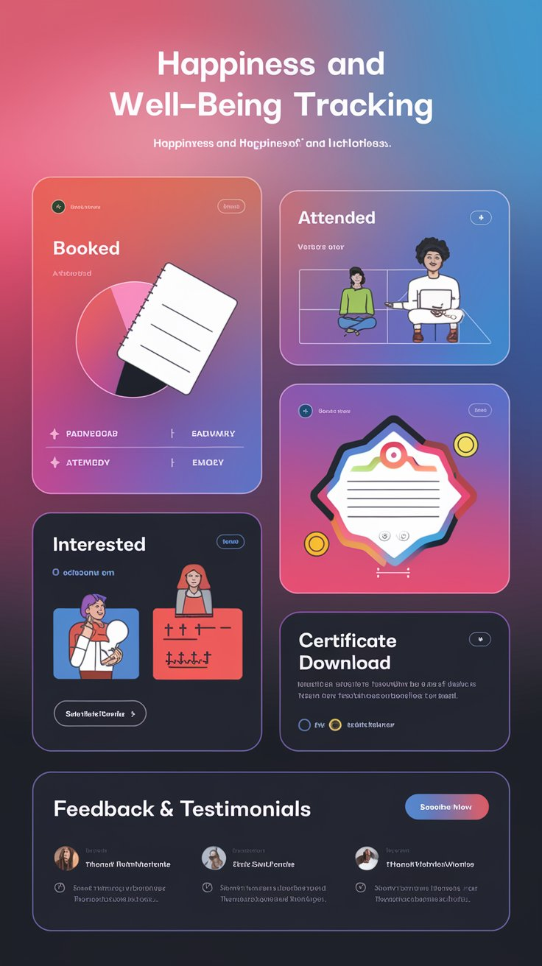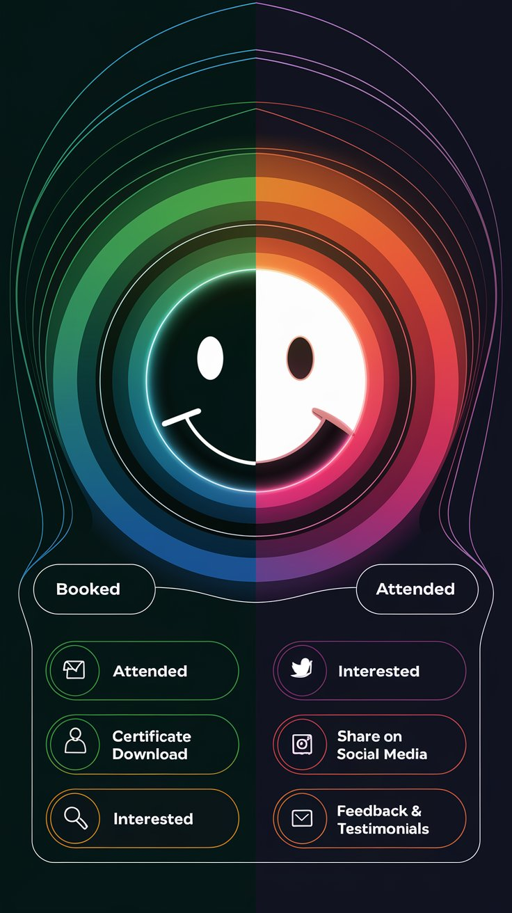  
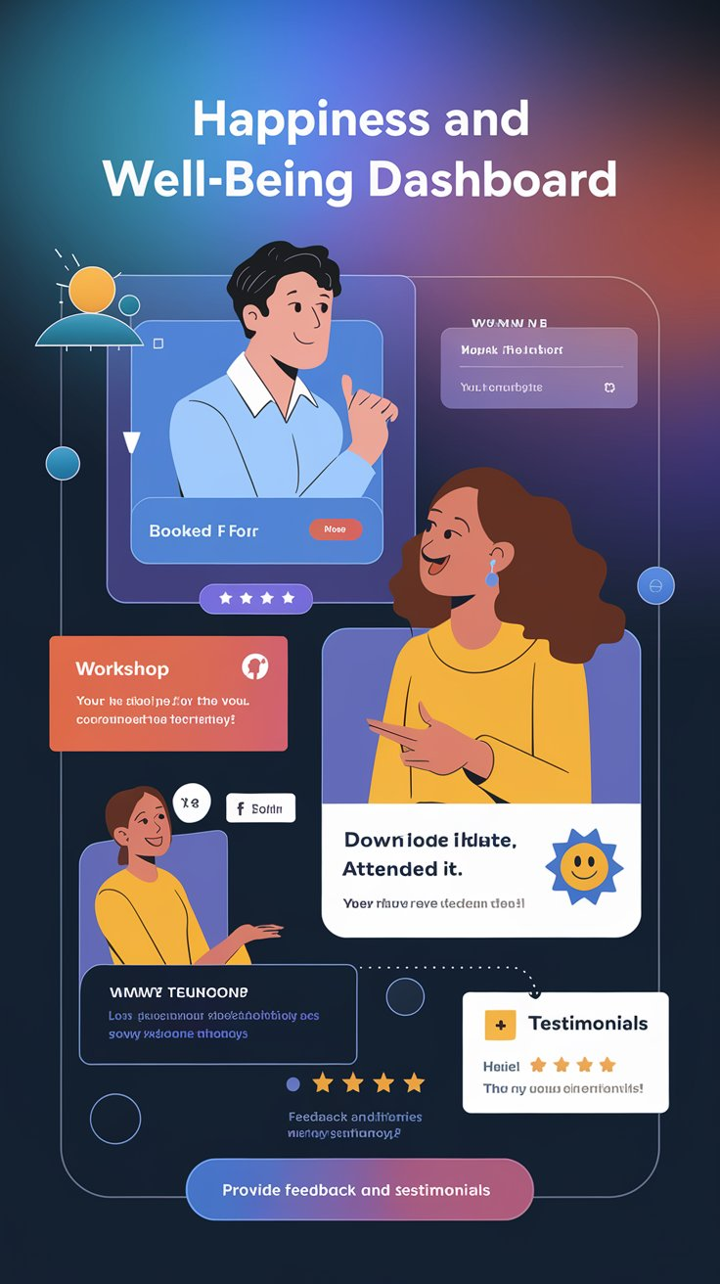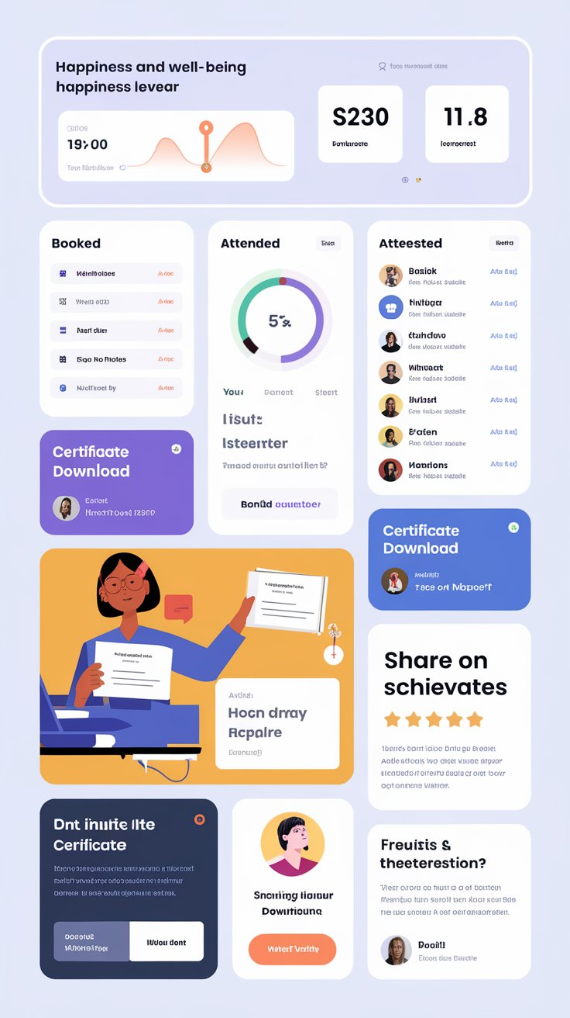**

* 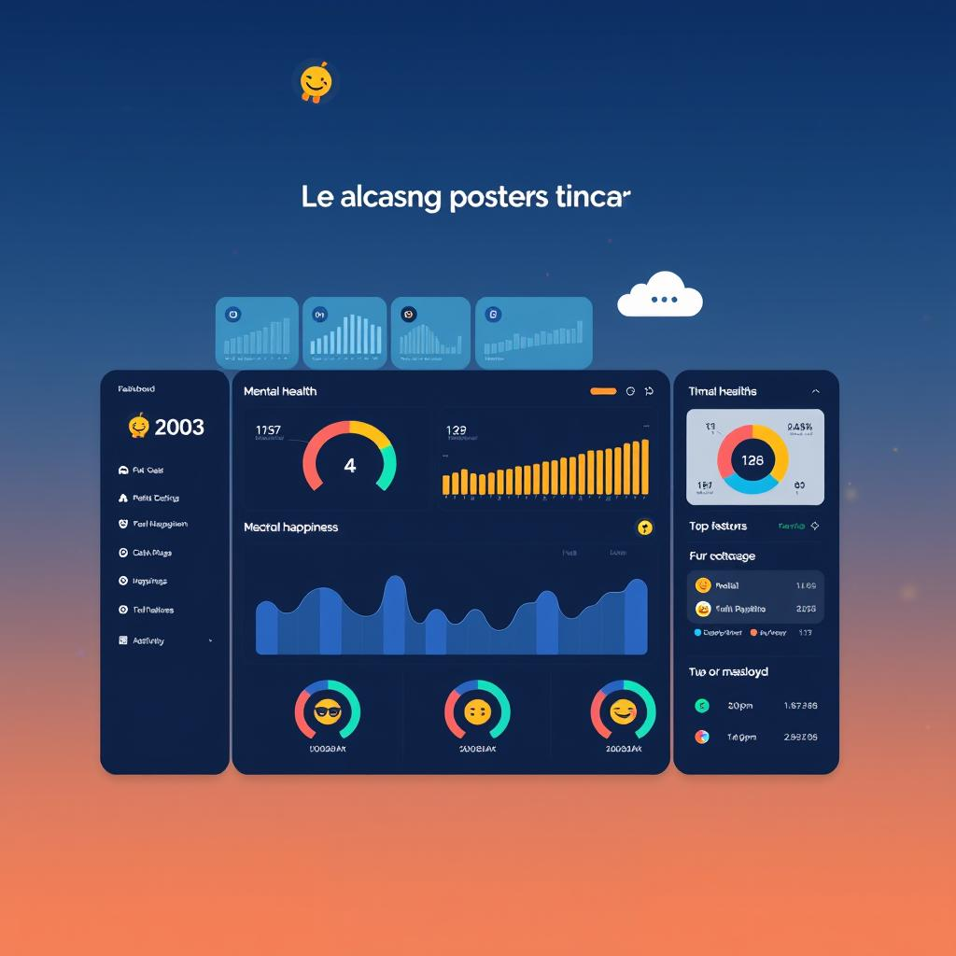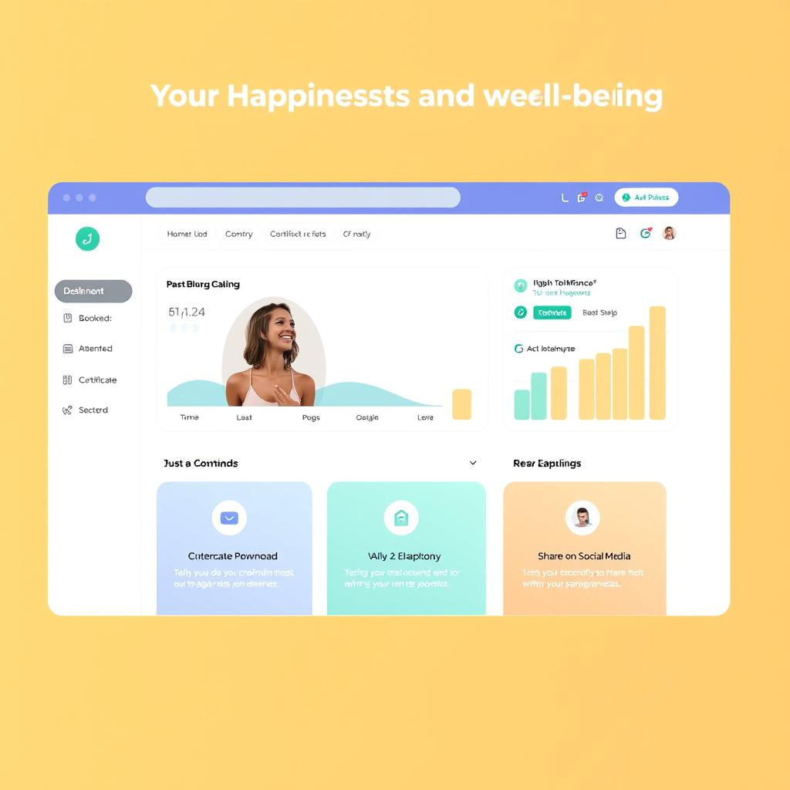
  + Workshops

Join our open events, which are hosted at various venues and are free to attend. Check our calendar for upcoming offline events with limited seats and detailed venue information.

* + - * Filter by Location, Date, Category
      * View Event Calendar

**Event Calendar (Table):**

|  |  |  |  |  |  |  |
| --- | --- | --- | --- | --- | --- | --- |
| **Event Name** | **Date** | Time | Location | Mode | Poster | Register |
|  |  |  |  |  |  | Form Link |
|  |  |  |  |  |  |  |
|  |  |  |  |  |  |  |

**Event Registration Form:**

**Full Name:**

**Organization (school/ college/ company/ other)**

**Designation (Student / other)**

**Age**

**Gender**

**Email Address:**

**Phone Number**

**Event name:** *(Auto selected)*

After registration : Email should go to every registered volunteer with a message

Also an email or website alert inbox go to the foundation

**CONFIRMATION MESSAGE SENT POST-REGISTRATION**

**Subject: Confirmation of Your Registration requesting for hosting [Event Name] on [Date] at [Venue]**

Dear Joyful [Full Name],

Thank you for registering for thee happiness workshop - [Event Name]! We’re excited to have you join us.

**Event Details:**

* **Date & Time:** [Event Date & Time]
* **Location:** [Venue]

Please note that some venues may require Aadhaar card verification for security. We look forward to seeing you there!

For any inquiries, feel free to contact us.

Warm regards,  
Mrs. Rumy Arora

Director

Ellipsis of Happiness Foundation  
989-171-2003

[info@ehappinessfoundation.in](mailto:info@ehappinessfoundation.in)

----------------------------------------------

* + - **Custom Happiness Workshop**

Request us to organize happiness and well-being workshops for your organization (online or offline) to achieve well-being needs pf your students, teachers, employees and resident community members.

* + - * Happiness Workshop Request Form:

**Preferred Date:** *(Date picker)*

**School/ Institute / Organization / RWA Name:** *(Text field)*

**Contact Person:** *(Text field)*

**Designation**

**Email Address:** *(Text field)*

**Phone Number:** *(Text field)*

**Preferred Workshop Format:** *(Dropdown: Online, Offline, Hybrid)*

**Number of Participants expected:** *(Dropdown or text field)*

**Workshop Focus Areas:** *(Checkboxes for options :Happiness , Inner Joy, Team Connect, Conscious Sleep (Yog-Nidra), IKIGAI, Stress Management, other)*

**Venue: Do you have**

**Auditorium**

**Seminar Hall**

**Classroom**

**Boardroom**

**Other**

**Upload Photo of venue**

**Do you wish to keep this requested session open for local community Yes / No**

**Additional Notes/Comments:** *(Text area for specific requests or details)*

After filling this form: Email should go with a message

MESSAGE

**Subject: Your Custom Happiness Workshop Request Details**

Dear [Contact Person],

Thank you for requesting Ellipsis if Happiness Foundation to host a custom happiness and well-being workshop at your [School/Institute/Organization/RWA Name] to enhance the happiness and well-being of your community.

We’ve received your request and will review the details to tailor the workshop to your needs. Our team will contact you shortly to finalize the arrangements.

* **Workshop Date:** [Preferred Date]
* **Organization:** [School/Institute/Organization/RWA Name]
* **Contact Person:** [Contact Person]
* **Designation:** [Designation]
* **Workshop Format:** [Preferred Workshop Format]
* **Number of Participants:** [Number of Participants expected]
* **Workshop Focus Areas:** [Selected Focus Areas]
* **Venue:** [Venue Details]

We will contact you soon to finalize arrangements. Looking forward to spreading happiness together!

Warm regards,  
Mrs. Rumy Arora

Director

Ellipsis of Happiness Foundation  
989-171-2003

--------------------------------

**Acceptance Letter for Happiness Workshop Booking**

**Subject:** Your Happiness Workshop Booking Confirmation

Dear [Contact Person],

We’re excited to confirm your booking for a custom **Happiness and Well-Being Workshop** with us! Below are the details:

**Workshop Details:**

* **Title of workshop:[ ]**
* **Date:** [Preferred Date]
* **Organization:** [School/Institute/Organization/RWA Name]
* **Workshop Format:** [Preferred Workshop Format]
* **Venue:** [Venue Details]

We’ll reach out soon to finalize the arrangements and ensure everything is set for a successful and enriching workshop.

Thank you for choosing us to help enhance the well-being of your community.

Best regards,  
[Your Organization's Name]  
[Contact Information]

*WEBPAGE DESIGN IDEA S/ VISUALS***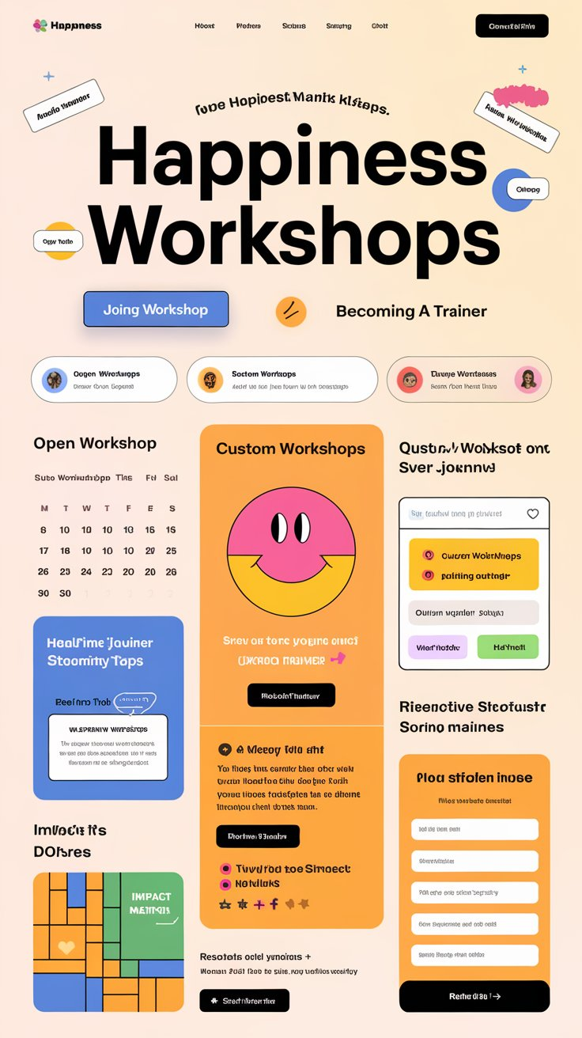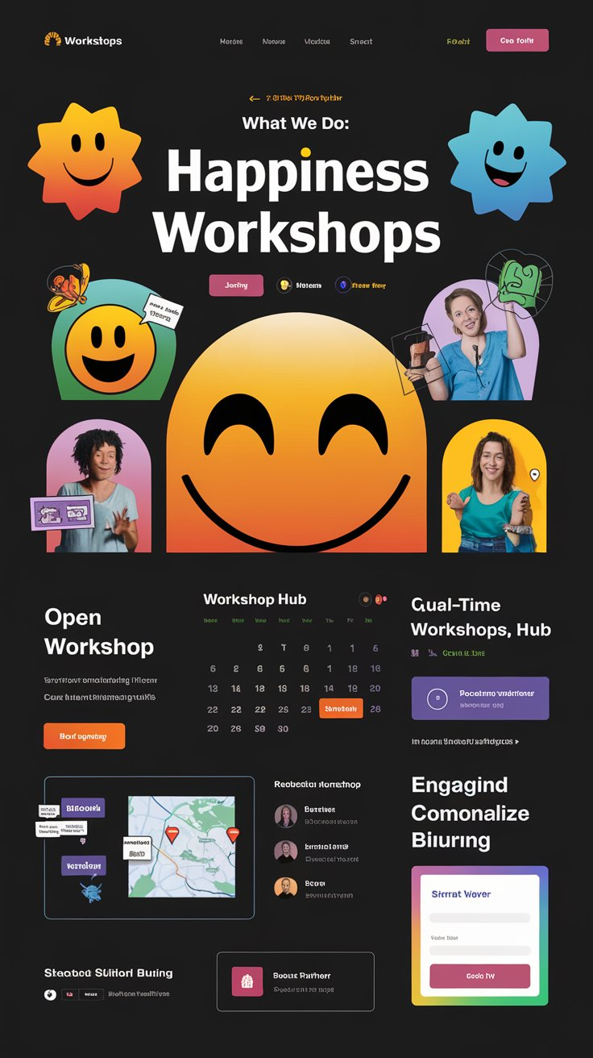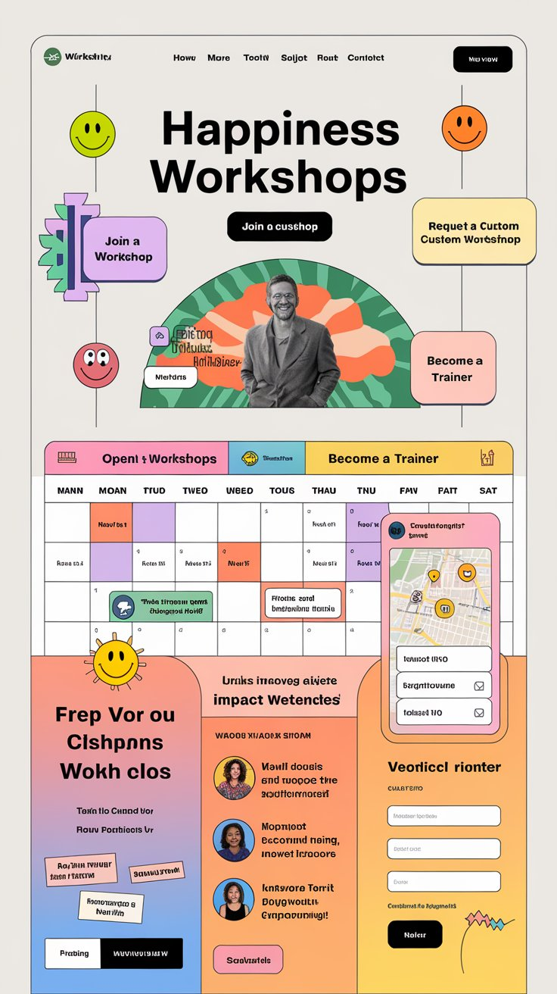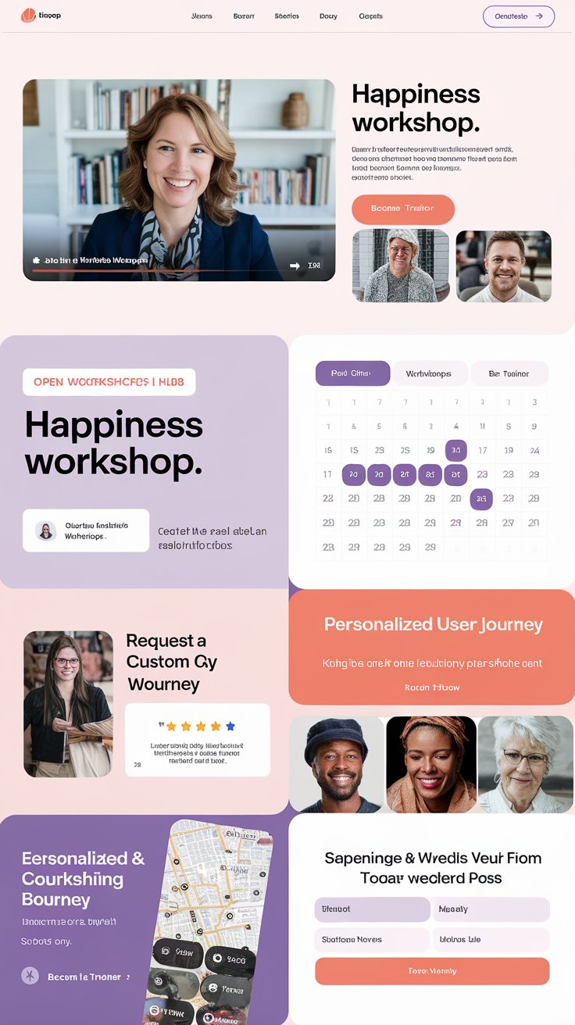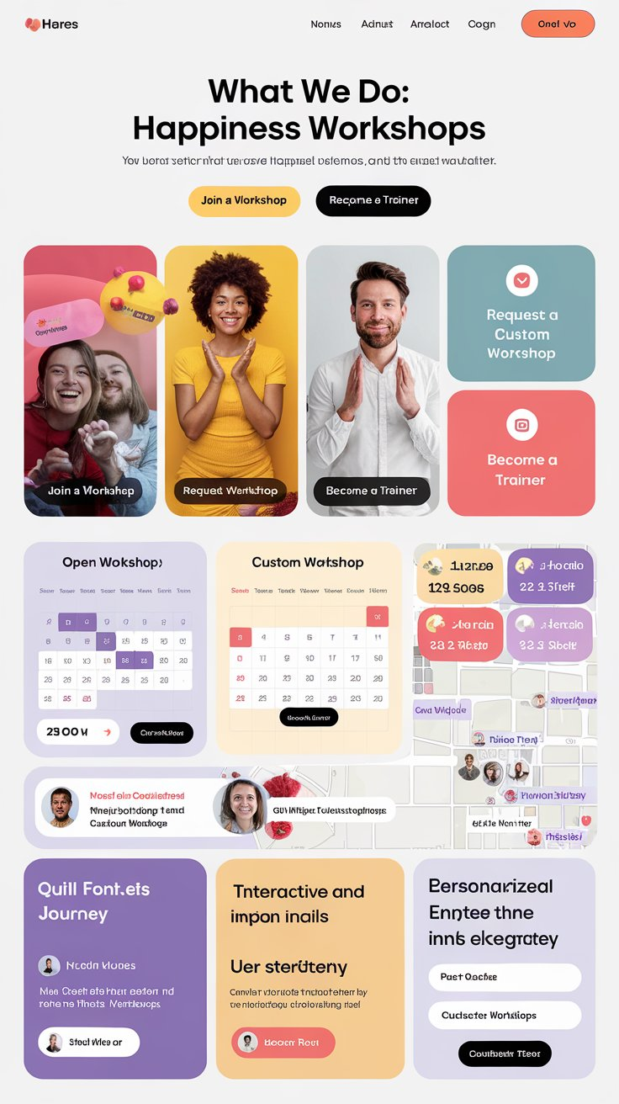**



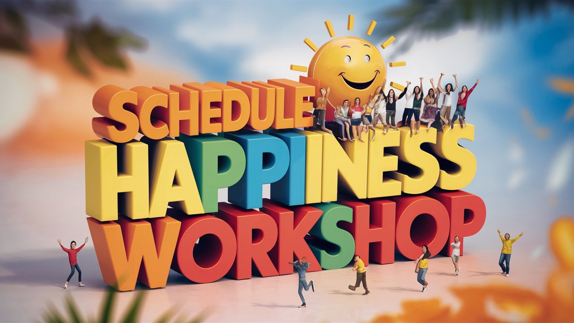

* **Happy Trainers:** Volunteer with us as Happiness and well-being Trainers.

Are you passionate about spreading joy and enhancing well-being? Join us as a **Happiness and Well-being Trainer**! As a volunteer cum trainer, you’ll have the opportunity to lead workshops that inspire positive change in communities, schools, and organizations. Share your expertise and passion and contribute to a movement that fosters happiness and mental well-being for all.

**Training Materials:** videos, audios, pdf, youtube links (No download)

* **Existing Trainers Gallery:**
  + **Name:** *(Clickable link to trainer’s profile)*
  + **Expertise:** *(Field showing primary areas of focus)*

**Volunteer as Happiness & Well-being Trainer**

* **A. Why volunteer as a Trainer?**
* **B On Boarding Process**
* **C. Steps to Apply**

**a. Why Volunteer as a Trainer?**

Becoming a volunteer Happiness and Well-being Trainer allows you to

* Make a meaningful impact
* Facilitate others to improve their Physical, mental, emotional, and spiritual well-being.
* Empower others with tools for happiness
* Gain valuable experience in well-being education
* Enhance your professional portfolio, and join a growing community of like-minded professionals dedicated to spreading happiness and well-being.

**b. On Boarding Process**

* Attend our experiential online / offline workshops.
* Meet and share your past training experience (if any)
* Upon approval, you'll lead workshops and training sessions nationally as volunteer trainer.

**c. Steps to Apply**

Ready to become a Happiness and Well-being Trainer? Here’s how to get started:

1. Complete the Trainer Volunteering Application Form
2. Submit Required Documents.
3. Attend experiential Orientation Session

**Registration Form Elements:**

**[Register as a Happiness and well-being Trainer]**

* **Full Name: (Text field)**
* **Organization (school/ college/ company/RWA/ other)**
* **Designation (Student / Professional / other)**
* **Age**
* **Gender**
* **Email Address:** *(Text field)*
* **Phone Number:** *(Text field)*
* **Area of Expertise:** *(Dropdown or checkboxes for areas of expertise)*
* **Experience:** *(Text area or dropdown for years of experience)*
* **Upload Resume/Credentials:** *(File upload option)*

**Submit Button:** *(To submit the registration form)*

*Letter sent to all who registered interest*

***Subject: Welcome to the Happiness Squad! 🌟***

Dear [Full Name],

Woohoo! 🎉 Your interest in becoming a Happiness and Well-being Volunteer-Trainer at Ellipsis of Happiness Foundation has officially brightened our day! Thank you for wanting to spread joy, positivity, and well-being far and wide. The world needs more people like you!

**Here’s a Quick Peek at Your Awesome Journey So Far:**

* **Full Name:** [Full Name]
* **Organization:** [Organization]
* **Designation:** [Designation]
* **Phone Number:** [Phone Number]
* **Area of Expertise:** [Area of Expertise]
* **Experience:** [Experience]

We’ve received your registration form and all the wonderful details you shared with us. Your enthusiasm for becoming a happiness hero has already made us smile, and we can’t wait to see the impact you’ll make!

**What’s Next?**

Sit tight! Our team of happiness enthusiasts is reviewing your application, and they’re already doing a little happy dance. 💃🕺 We’ll be in touch soon with the next steps, exciting updates, and opportunities to get involved. Keep an eye on your inbox—you never know when a burst of happiness might pop up!

**While You’re Waiting…**

Why not take a moment to do something that makes you smile? Whether it’s dancing to your favorite song, enjoying a cup of your favorite tea, or just sharing a laugh with a friend, remember that every little moment of joy counts. 😊

If you have any questions or just want to share a happy thought, feel free to reach out to us at [989-171-2003]. We’re always here to spread some extra cheer!

Thank you for being you, [Full Name]. We’re excited to be part of your happiness journey!

With lots of smiles,

Mrs. Rumy Arora

Director

Ellipsis of Happiness Foundation  
989-171-2003

*WEBPAGE DESIGN IDEA S/ VISUALS*

***Header:***

* ***Logo:*** *A bright and cheerful logo representing happiness and well-being.*
* ***Navigation Menu:*** *Sticky top menu with smooth scroll to sections:*
  + *Home*
  + *Why Volunteer*
  + *Onboarding Process*
  + *Steps to Apply*
  + *Trainers Gallery*

***Hero Section:***

* ***Background:*** *A full-width, vibrant image of a diverse group of happy people in a workshop setting, radiating positivity and joy.*
* ***Headline:*** *"Become a Happiness and Well-being Trainer!"*
* ***Subheadline:*** *"Spread joy, inspire change, and foster well-being in your community."*
* ***Call-to-Action Button:*** *"Apply for Volunteering" (scrolls down to the registration form)*

***Section 1: Happy Trainers***

* ***Title:*** *"Happy Trainers: Volunteer with Us!"*

***Section 2: Training Materials***

* ***Title:*** *"Training Materials"*

***Section 3: Existing Trainers Gallery***

* ***Title:*** *"Meet Our Trainers"*

***Section 4: Why Volunteer as a Trainer?***

* ***Title:*** *"Why Volunteer as a Trainer?"*

***Section 5: Onboarding Process***

* ***Title:*** *"Onboarding Process"*

***Section 6: Steps to Apply***

* ***Title:*** *"Steps to Apply"*

***Section 7: Registration Form***

* ***Title:*** *"Join Us as a Happiness and Well-being Trainer!"*

***Footer:***

* ***Content:***
  + *A cheerful note: "Thank you for spreading happiness with us*

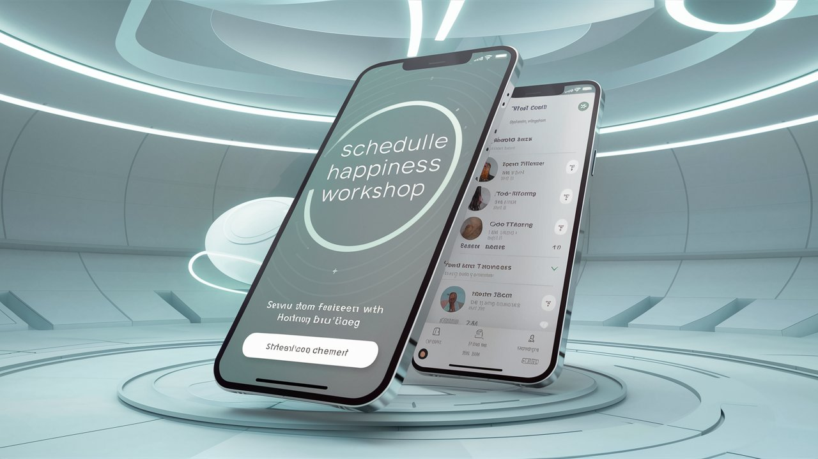

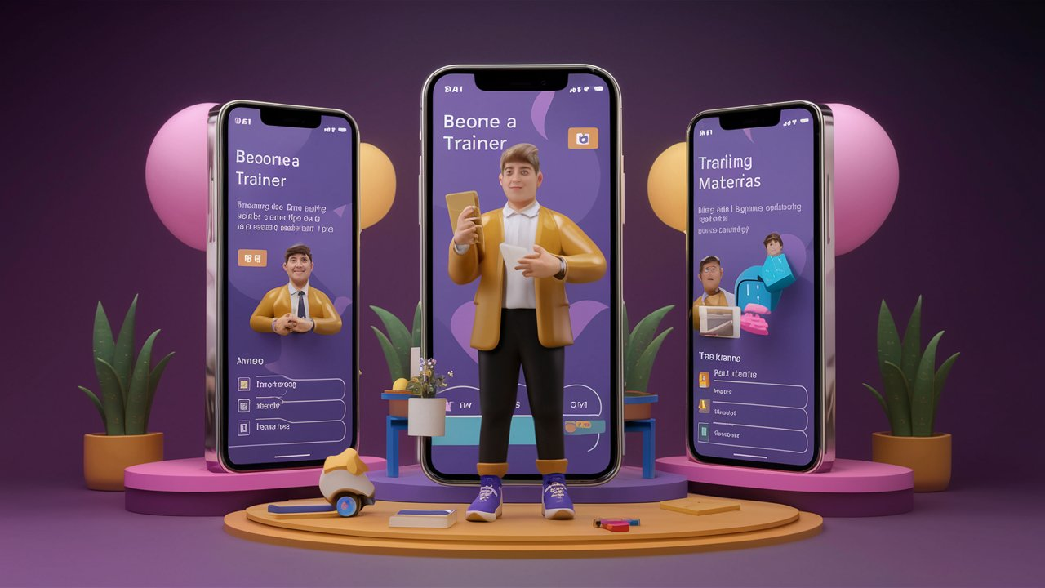

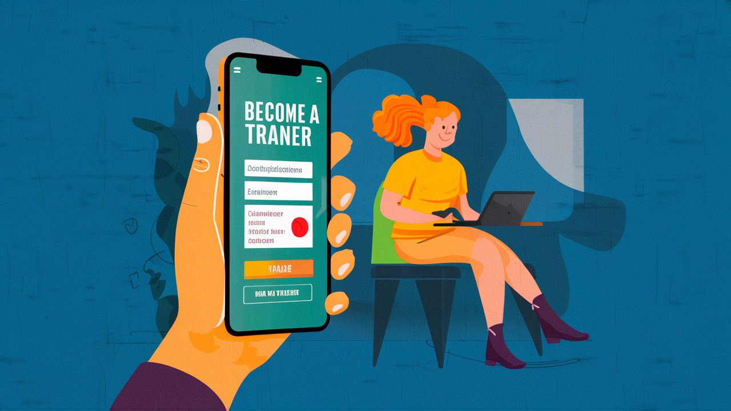

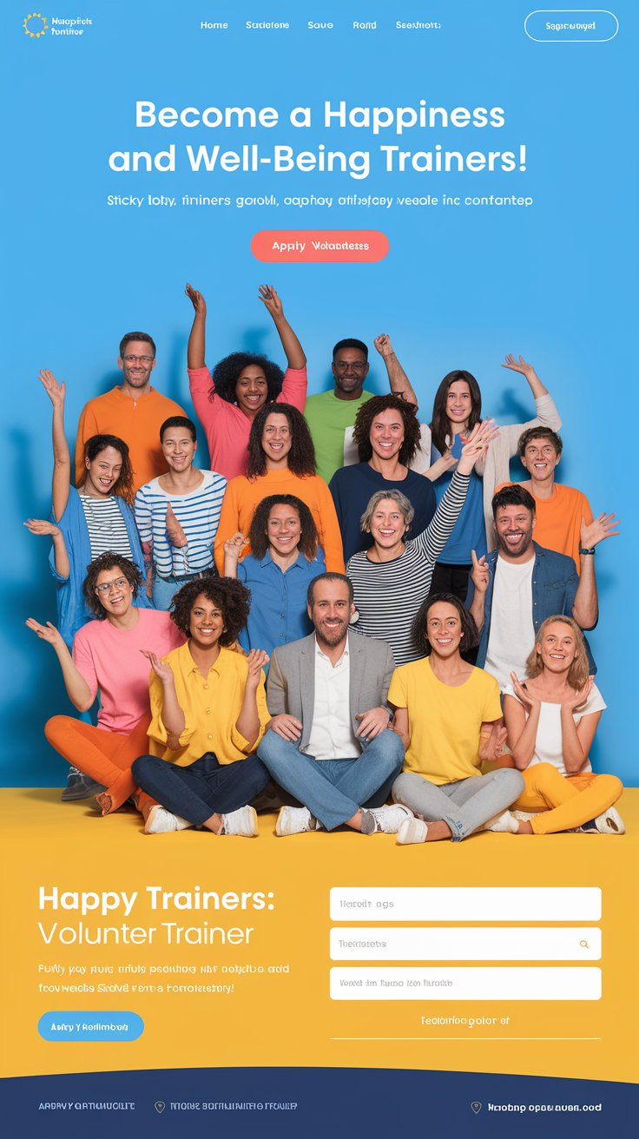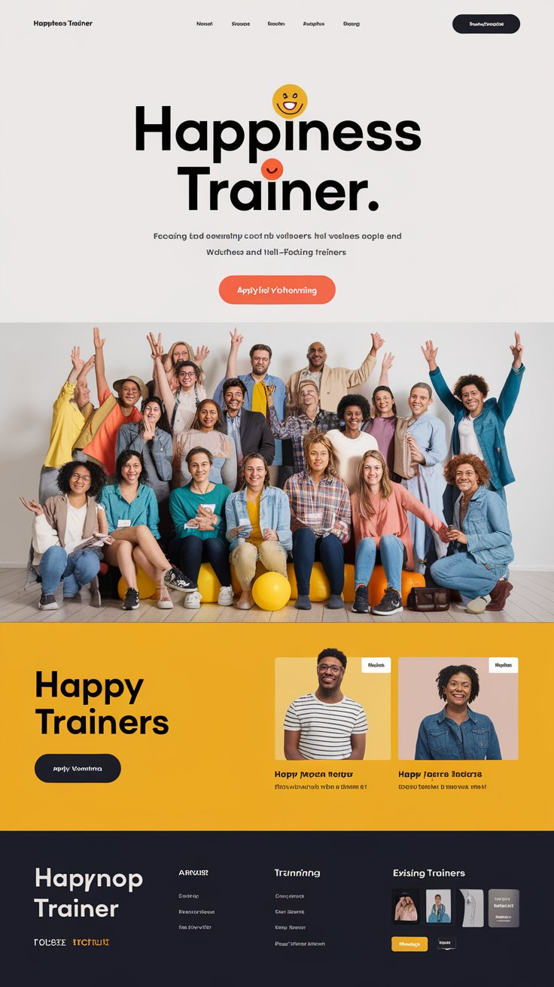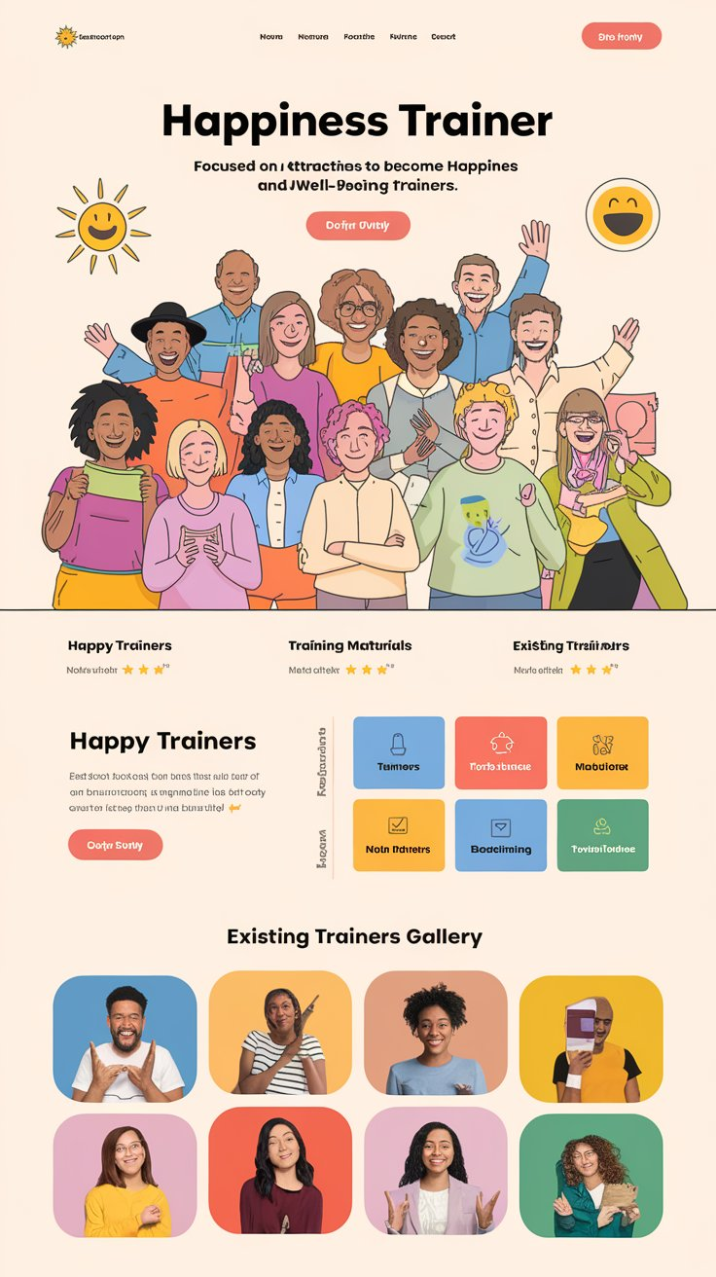

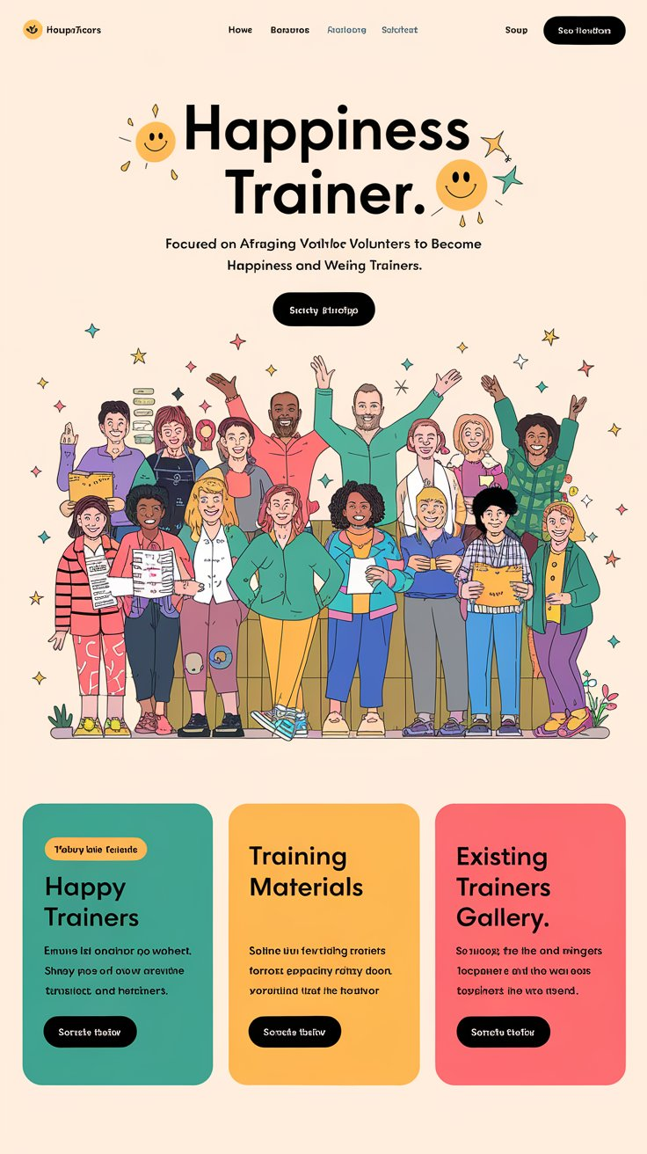

**2.** e-Happiness Bank

(short description-- **E**ngaging meaningfully with *Joycoins* for enhancing the cycle of positivity and support.)

**Details**: -The e-Happiness Bank is our innovative initiative aimed at creating a supportive and engaging community via joyful & meaningful activities. By engagement, members can earn and redeem happiness points[***Joy Coins***], fostering a cycle of positivity and support among the community members and society as a whole.

a. What is e-Happiness Bank

b. Earn and Spend *JoyCoins*

c. My Passport

d. Community Happiness Experience Zone

**a. What is it**

The e-Happiness Bank is a pioneering community-driven platform. It is designed to cultivate well-being, personal growth, and social cohesion. It facilitates earning and spending of non-monetary "Happiness Credits" through various activities. This innovative system encourages members to engage in enhancing happiness by community service, positive skill sharing, well being initiatives, & enriching personal and community life.

At the heart of the Happiness Bank is a unique currency system. Here members gain Happiness Credits by participating in activities that enhance their own well-being and contribute positively to the community.

The portal features a dynamic debit and credit system, where members earn credits by contributing to the community and spend credits to participate in offerings. This digital platform is designed to be inclusive and accessible, supporting a wide range of activities that can be conducted online or through meetups at verified locations, ensuring flexibility and convenience for all users.

Membership in the Happiness Bank is established through volunteer recommendations from existing volunteer members or via thorough verification processes, fostering a trusted and secure happiness community environment. The app integrates personalization and gamification elements to enhance user engagement, making the experience rewarding and enjoyable. Regular feedback and continuous improvement mechanisms are integral to the app, allowing it to evolve according to community needs and preferences.

In summary, the Happiness Bank app is not just a platform but a movement towards fostering a happier, more connected, and resilient community. It reimagines the concept of currency and marketplace, creating a space where every member can contribute to the collective well-being and find support in their journey towards personal happiness and fulfillment.

**Members: Join | Recommend**

b. **Earn and Spend *JoyCoins***







The e-Happiness Bank encourages community engagement and personal inner growth through its innovative Points system called as ***JoyCoins***. Here's how it works:

**JoyCoins- Points System**

|  |  |  |  |
| --- | --- | --- | --- |
| **Category** | **Joyful Tasks** | **Joy Coins Earned** | **Description** |
| **Welcome** | Register as a new member | 100 | Initial bonus for joining the community |
| **Engagement** | Participate in an event/activity | 20 | Active involvement |
|  | Host an event | 40 | Leading community activities |
|  | Complete a feedback survey | 10 | Contributing valuable insights |
| **Content Creation** | Submit blog/article/video (per acceptance) | 10-50 | Sharing knowledge and creativity |
| **Community Support** | Provide venue for an event | 50 | Facilitating community gatherings |
| **Social Impact** | Submit video testimonial | 20 | Personal contribution validation |
|  | Build volunteers | 30 | Expanding the community |
| **Special Roles** | Become a *Dial-Helpline* volunteer | 50 | Contributing to mental well-being |
| **Networking** | Create corporate networking opportunities | 40 | Expanding the foundation's reach |
| **Consistency Gems** | Volunteering Consistency (Auto credit) | 100 | Involvement bonus |
| **Gratitude Tokens** | Foundation Gratitude (Auto Credit) | 200 | Special volunteering |
| **Note:** In the Happiness Bank, your progress and points-**JoyCoins** remain completely private—no one can see others' points. You can choose to view your own progress at intervals of once a day, once every 3 days, once every 7 days, once every 14 days, or once a month. Our focus is on personal growth and well-being without competition. Focus on increasing engagement and once a while see your happiness -Joy coins -bank balance 😊! **If you wish to opt out of Points system completely, you can send request to webmaster@ehappinessfoundation.in** | | | |

**Suggested e-Happiness Bank activities**

Points automatically generated post activities by webmaster- **Joyful Guardian**.

**1. General Activities [Hybrid mode]**

We encourage routine or unique nature interactive activities that involve personal engagement.

* Share a Positive News [Article / Video ]
* Write a Thank-You Note to someone in the community. [Article / Video ]
* Participate in a Yoga Session: Join **online / offline**
* Cook a Meal for a Neighbor
* Offer Bedtime storytelling support for kids on [**community VC -Videoconferencing portal]**
* Share a Motivational Quote in **community forum**.
* Conduct Guided Meditation session.[online]
* Read story to a Child [online].
* Record a fun dance / dialogue **[Reels**].
* Participate in a Meditation Challenge.**[Hybrid VC]**
* Involve other in Your Hobby.[Online VC]
* Write a Short Story.[Blog]
* Share Feedback about community contributions.
* Host Life Hacks session

**2. Community Engagement**

* Generate Birthday Cards [Online]—Harsh ji we need to create this tool as we discussed like certificate generator option
* Organize a Book Club Meeting [virtual or in-person].
* Host a Virtual Coffee Chat.
* Participate in a Happiness Charity Run in community[Online].
* Host a movie screening for the community.
* Organize a Group Fitness Class.[Online / hybrid]
* Share a Recipe.[Online / hybrid]
* Organize a Talent Show in community[Online / hybrid]
* Conduct a Science Experiment with kids.
* Photography Walk [Community Happy spots]
* Host a Cooking Class.[Online]
* Organize a Puzzle-Solving session.
* Lead a small group for a Nature Walk.
* Organize a Cultural Exchange between communities.
* Organize a Community Potluck.
* Organize a Music Jam Session.
* Bike Ride for Happiness fund raise.
* Organize a Mindfulness Retreat
* Organize in a Virtual Run Challenge.
* Host a Pet Care Workshop & more [ Online]

**3. Social Impact [Upload Photos]**

* Donate Clothes to maid servant, car cleaner etc.
* Lead a Cleanup Drive
* Donate Books for the centre of happiness book corner.
* Help an elderly Neighbour with Groceries.
* Wellness Check - Visit elderly neighbour to check on their well-being.
* Promote happiness to community during your national and international family travel [**Foundation Posters Download**].
* Conduct a Wellness Check - Call or visit someone to check on their well-being

----------------------------------------------------------





**HAPPINESS PASSPORT**

{They have to login to see this}

**Profile Webpage Content (H.E.A.R.T. Framework): [AI involvement to create or check them]**

**Joycoins-{Count}**

**Social**

**1. Header Section**

* **Profile Picture**: A professional or friendly photo of the volunteer.[Upload]
* **Name**: Full name of the volunteer.
* **Title**: e.g. Director, Staff, Volunteer, Venue Coordinator, Happiness and well-being promoter, Trainer, Well Wisher)
  + - **Director**: Chief Happiness Architect
    - **Staff**: Happiness Operations Guide
    - **Volunteer**: Joyful Service Ambassador
    - **Venue Coordinator**: Happiness Event Maestro
    - **Happiness and Well-being Promoter**: Well-being Advocate
    - **Trainer**: Happiness Mentor
* **Joined Date**: The date OF JOINING .[Account creation date]

**2. Highlights**

**Brief Bio**: A short paragraph introducing the volunteer, including their background, current role.[Edit]

* **Personal Quote**: inspiring or personal quote from the volunteer.[Edit or taken from Login data]
* **Age**: [Edit]
* **PROFESSIONAL Role (If Any)**: Current or past professional role and experience.
* **Scholarship Received**: Amount !!!

Details of any scholarships or financial aids received from Ellipsis of Happiness Foundation (OPEN FOR ONLY THOSE WHO HAVE VOLUNTEERED FOR 3 MONTHS with certificate from foundation. The system should automatically put a schoalrship badge in his or her account and on a list of overll receivers of schoalrships and on leaderboard too)

**3. Engagement**

* **Volunteer Activities**: A list of the volunteer’s main activities and roles within the organization.[Auto from attended, trained]
* **Hours Volunteered**: Total number of hours volunteered.
* **JoyCoins**: Points earned through engagement and contributions.
* **Collaborative Teams**: Any specific teams or groups the volunteer is part of (community group) with team members name.

**4. Achievements**

* **Funds Raised**: Total amount of funds raised by the volunteer .
* **Recognitions and Awards**: Any awards, recognitions, or special mentions received.
* **Key campaigns**: All above events from engagement. Highlights of significant campaigns the volunteer has contributed to.

**5. Relationships**

* **Community Impact Statement**: A brief description of how the volunteer’s work has impacted the community or organization.[from the AI OR ADMIN]
* **Testimonial**: A testimonial for another volunteer contribution.[ message][Search all volunteers by name and Tag them]
* **Touchpoints** 
  1. **Media and Publications**
* **Photos and Videos**: showcasing the volunteer’s activities an[upload].
* **Articles and Mentions**: Links to articles, blog posts, or news mentions.
  1. **Contact and Connect**
* **Social Media Links**: Links to the social media profiles.
* **Contact Information**:[Auto]

**DOWNLOAD PASSPORT [PDF]**

**STRUCTURE**

**Example Structure with H.E.A.R.T. Framework:**

**[Header Section]**

* **Profile Picture**
* **Name**
* **Title**
* **Joined Date**

**[Highlights]**

* Brief Bio
* Personal Quote
* Age
* Professional Role
* Scholarship Received (Auto fillup)

**[Engagement]**

* Volunteer Activities
* Hours Volunteered (Auto fillup)
* Joycoins (count autofill up)
* Collaborative Teams

**[Achievements]**

* Funds Raised (Auto)
* Recognitions and Awards (Auto)
* Key Campaigns (

**[Relationships]**

* **Community Impact Statement**
* Testimonial
* **Touchpoints**

**Download Happiness Passport [PDF file]**

--------------------------------------------------

**3. Dial Happiness-Just a call away**

***Dial Happiness* Number: 98-9171-2003**

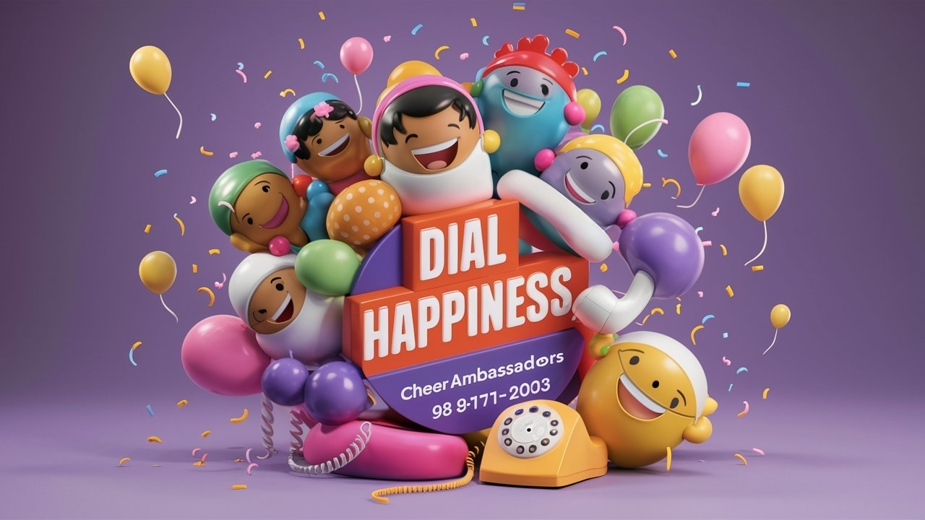

**[Timings : Weekdays 11:00am to 1:00pm, Weekends 10:00am to 1:00pm & 3:00pm-6:00pm]**

{Brief}: Dial our Happiness Hotline for an instant mood lift! Our trained ***Cheer Ambassadors*** are here to listen, support, and brighten your day, at no cost to you.

**{Details}:**

**What is *Dial Happiness*?**

*Dial Happiness* is our dedicated e-Happiness Call Centre where we’re just a call away from bringing a smile to your face. This unique service is part of our ongoing mission at the Foundation to promote well-being. Whether you're seeking happiness and well-being advice and guidance on issues that matter to you, or need information about the ellipsis happiness foundation, *Dial Happiness* is here to help.

**How to Use Joy Dial**

1. **Call Us:** Dial 98-9171-2003 to speak with a happiness consultant.
2. **Explain Your Needs:** Share your questions, concerns, or type of assistance you need.
3. **Receive Support:** Our JoyDial assistants will provide you with the necessary guidance.
4. **Follow Up:** Expect follow-up calls to ensure your needs are adequately addressed

**Join the Global Movement!**In alignment with the UN’s International Day of Happiness, we're committed to spreading joy and well-being across the world. The International Day of Happiness is celebrated on **March 20th** each year.

**SPECIAL MENTION**: Our number **98-9171-2003** is more than just digits—it's a tribute to **20th March (20-03),** the UN's International Day of Happiness. When you **Dial Happiness,** you're dialing into a global celebration of joy!

[Become a Cheer Ambassador] **(Button/Link)**

**What more it offers:**

* **Community Engagement:** Joy Dial helps you find volunteer opportunities, book happiness workshops, join workshops, and participate in community tasks.
* **Confidential & Supportive**: These conversations are not psychological therapies or cure. Your conversations are private and confidential.
* **Personalized Assistance:** Each call is personalized to ensure you receive specific information.

**Important Note:**

*These conversations are meant to bring positivity and uplift your mood. They are* ***not psychological therapies or cures*** *but rather a friendly, supportive chat to brighten your day.*

Dial Happiness is more than just a call centre. It’s a lifeline for those seeking and giving happiness. It has the potential to be the lifeline within our community. Join us & support us, to let us help you and many more walking on journey to enhance well-being and joy.  
  
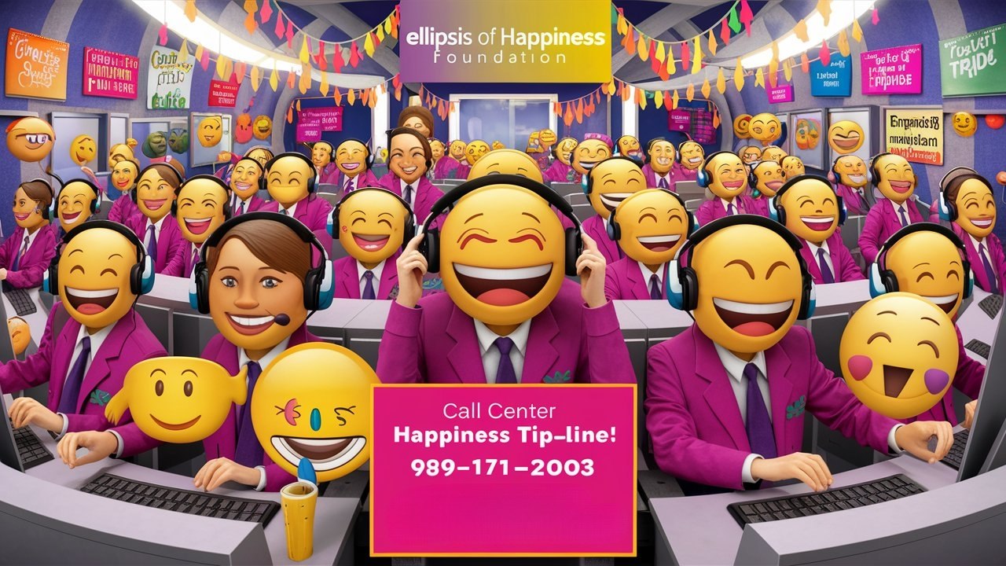

--------------------------------------

**4.Mr. & Miss Happiness™:**

**sample websites** [**https://www.missuniverse.com/about**](https://www.missuniverse.com/about)

<https://www.missmrsindia.com/> [https://www.mrsindiaprideofnation.com](https://www.mrsindiaprideofnation.com/)

<https://rubarugroup.in/rubaru-group-mr-mrs-junior-audition> <https://www.aleeclub.net/>

In a world that sometimes feels mentally heavy, Mr. and Miss HappinessTM annual event of Ellipsis of Happiness Foundation is designed to remind us to be joyful. This is non-competitive event isn’t just about a title; it’s sparking an inner revolution. Join us in making happiness go viral, one ***growing smile*** at a time.

**Tagline:** Where Happiness Takes Center Stage

* **Call to Action:** Register for Essay Submission | Participant | Volunteers| Directorship

*(Keep the buttons inactive, but form needs to be prepared, sample forms in links above)*

* **A Unique Event for Everyone:**
* Welcome to **Mr. and Miss HappinessTM**, where the few criteria for winning the title is (a) growing acceptance of your ongoing happiness volunteering impact before the finale and (b) happiness plan potential for spreading happiness and well-being among community after the finale! This isn’t a typical pageant; this is not a beauty pageant. It’s a celebration of life, positivity, well-being commitment and the simple delightful intention to do something to make the world a little better and positive. Mr. and Miss Happiness is non-competitive pageant and is open to juniors, teens, adults, and elders alike, bringing together all generations in the pursuit of joy. This event is a unique chance to showcase your unique brand of happiness and brush it all over for enhancing community well-being.

It acts as catalytic centre stage, a bridge that can inspire the millions to touch hundreds of lives around joyfully! Join and support us as Ellipsis of Happiness Foundation bring together from all walks of life to share, celebrate, and spread happiness.

**Eligibility : P**articipants must showcase evidence their consistent joyful service for community for a minimum 15-days on the ellipsis if happiness platform.

**About the Event:**Our mission is simple: to create a ripple effect of happiness that spreads far and wide. Mr. and Miss Happiness is open to 5 age categories, bringing together all generations in the pursuit of joy. Participants will not only get the titles but post participation, as Chief Happiness Ambassadors will promote happiness and well-being in the Indian communities on behalf of Ellipsis of Happiness foundation.

* **Event Flow:** From the first audition to the grand finale, Mr. and Miss Happiness is a journey designed to increase happiness levels in each participant. Whether you’re competing, volunteering, or cheering from the sidelines, every moment is a step towards creating a happier world, by making a happier You!
* **Mr. and Miss Happiness Award Categories**
  + - **Junior Joy (Ages 6-12years)**
      * Celebrating the boundless energy and creative spirit of our youngest happiness ambassadors.
    - **Teenager's Triumph (Ages 13-18 years)**
      * Empowering teenagers to showcase their vision of happiness and well-being in today’s world.
    - **Youth Radiance (Ages 19-25 years)**
      * Highlighting the vibrant potential of young adults as they carve their paths toward lifelong happiness.
    - **Emerging Adults (Ages 26-35 years)**
      * Celebrating those in the early stages of their careers and personal lives as they balance growth and joy.
    - **Prime Happiness (Ages 36-49 years)**
      * Honoring the wisdom and experience of adults who inspire others through their journey of happiness.
    - **Seenager’s Gleam (Ages 50+ years)**
      * Recognizing the enduring happiness and resilience of those who continue to shine brightly in their golden years.
* **Participate**

**Happiness is Involvement, Involvement & Involvement**   
Want to be part of something special? Whether you're participating, volunteering, sponsoring, or as our sincere well-wishers, your involvement at each level will make this event shine even brighter. Join us as participant for the most coveted Mr and Miss Happiness annual event, an experience that is committed to promote happiness and well being.

* How to Register (sample form.. <https://www.mrsindiaprideofnation.com/>)
* Participation Guidelines (will be shared)
* Training Workshops (Pre-event sessions)
* Submit Your Entry (Online form)
* FAQ (will be shared)
* **Event Flow:**
  + - Auditions (Date & Locations)-To be announced
    - Workshops (Preparation sessions info) Details To be announced
    - Grand Finale (Final Event Date) – To be announced
* **Gallery**
  + - * **Photos & Videos**: Collections from the event, auditions, and workshops.
      * **Media Coverage**: Links to news articles, interviews, and features about the event.

**Why This Event is Different:**

* **Scholarships That Matter:** Winners don’t just walk away with a crown; they become ambassadors of happiness. And it gets better—these title winners cum Ellipsis happiness ambassadors will personally award scholarships to future happiness-makers in various categories.
* **Corporate Happiness Awards:** Happiness isn’t just personal; it’s professional too. Ellipsis of Happiness Foundation will honor companies that are leading the way in creating joyful workplaces, with awards presented by Mr. and Miss Happiness winners. It’s recognition for their purposeful efforts in building joyful communities!
* **No Judging, Just Joy:** Forget about conventional competitions. Here, everyone’s a winner! Whether it’s a child’s innocent smile or a senior’s wise words, we celebrate all forms of happiness.

---------------------------------------

**SPOTLIGHT**

* **Mr. and Miss happinessTM Event Volunteer:** Be part of something extraordinary! As a volunteer for this special annual gala event spread across 3 months plus of involvement (evidence based involvement is a process of audition), you’ll help bring this event to life and contribute to spreading happiness far and wide. Sign up now and join as local team volunteers - *Harshvardhans* - the joy makers. **REGISTER BUTTON**

**--------------------------------------------**

* **Contestants (all photos)**

Volunteer Scholarships (Happiness Passport file upload)

Corporate Happiness Awards (Registration)

Apply

1. For Directorship

2. For Sponsorships

3. For Scholarship

4. For Volunteering / Internships

* **Happiness Travel Diaries**
* **More---** Gallery

Press

Mr and Miss Happiness Magazine

FAQs

Contact

Important Links (https://mrsindia.co/online-auditions/)

-Disclaimer

-Privacy policy

FORM

**Mr. and Miss HappinessTM – Junior/ Teenager/ Youth Category Registration Form**

**Eligibility Criteria**

* **Age:** 6 to 49+years
* **Categories**
  + **Junior Joy (Ages 6-12years)**
    - Celebrating the boundless energy and creative spirit of our youngest happiness ambassadors.
  + **Teenager's Triumph (Ages 13-18 years)**
    - Empowering teenagers to showcase their vision of happiness and well-being in today’s world.
  + **Youth Radiance (Ages 19-25 years)**
    - Highlighting the vibrant potential of young adults as they carve their paths toward lifelong happiness.
* **School/College:** Currently enrolled in any educational institution

**Personal Information**

1. **First Name**: *First Name*
2. **Last Name**: *Last Name*
3. **Age**: *Age*
4. **Grade/Class**: *Select your current grade/class*
5. **School/College Name**: *Enter your school/college name*
6. **City**: *City*

**Contact Details**

1. **Mobile Number**: *Mobile Number*
2. **Email Address**: *Email Address*

**Physical Attributes**

1. **Height**: *Height (in cm)*
2. **Weight**: *Weight (in kg)*
3. **Upload Photo**: *Upload a recent photo (Picture 1, Picture 2, picture 3)*

**Extracurricular Activities**

1. **List your hobbies and interests**: *Enter details*
2. **Have you participated in any school/college events?**: *Yes/No*
3. **Briefly describe a recent achievement**: *Enter achievement details*

**Audition Details**

1. **Happiness Passport Link**:________________________________________
2. **Upload a 1-2-minute video (in Hindi or English) introducing yourself, your past community happiness contribution and why do you think you can become Mr or Miss Happiness**: *Upload video link*

**User can Update it with new data needed till the last date when form will be locked up**

* + Give Link to their Happiness Passport(based on their login account)
  + Link to contestant photo page with votes count on video

**Parental Consent**

1. **Parent/Guardian Name**: *Enter name*
2. **Relationship:** Father/ Mother/ Other
3. **Parent/Guardian Contact Number**: *Enter contact number*
4. **I hereby consent to my child's participation in the Mr. and Miss Happiness event**: *Yes/No*

**Declaration**

* I confirm that the above information is true to the best of my knowledge.

I agree to abide by the **Eligibility Criteria** of the Mr. and Miss Happiness event.

**Submit Button**

FORM

**Mr. and Miss HappinessTM – Emerging Adult/ Prime Happiness / Seenager Category Registration Form**

**Eligibility Criteria**

* **Age:** 26 to 49+years
* **Categories**
  + **Emerging Adults (Ages 26-35 years)**
    - Celebrating those in the early stages of their careers and personal lives as they balance growth and joy.
  + **Prime Happiness (Ages 36-49 years)**
    - Honoring the wisdom and experience of adults who inspire others through their journey of happiness.
  + **Seenager’s Gleam (Ages 50+ years)**
    - Recognizing the enduring happiness and resilience of those who continue to shine brightly in their golden years.

**Occupation**: Should be currently occupied in any organization in India.

----------------------------------------------------------------------------

**Category Selection:**

* Please select your category:
  + Youth Radiance (Ages 19-25)
  + Prime Happiness (Ages 36-49)
  + Seenager’s Gleam (Ages 50+)

**Personal Information:**

* **First Name:** *(Required)*
* **Last Name:** *(Required)*
* **Date of Birth:** *(Required)*
* **Gender:** *(Required)*
  + Male
  + Female
  + Other
* **Marital Status:** *(Required)*
  + Single
  + Married
  + Separated
  + Divorced
  + Widowed

**Contact Information:**

* **Mobile Number:** *(Required)*
* **Email Address:** *(Required)*
* **Communication Address:**
  + Address Line 1: *(Required)*
  + Address Line 2:
  + City: *(Required)*
  + State: *(Required)*
  + Postal Code: *(Required)*

**Physical Attributes:**

* **Height:** *(Select from a dropdown menu)*
  + 5'0" – 5'3"
  + 5'4" – 5'7"
  + 5'8" and above
* **Weight:** *(In KGs)*
* **Vital Stats (In Inches):**
  + **Bust/Chest:** *(Required)*
  + **Waist:** *(Required)*
  + **Hips:** *(Required)*

**Ellipsis Level of Happiness:**

* **Please select the level of happiness you regularly share in your community:**
  + **Body Fitness:** Through activities like yoga, exercise, or sports.
  + **Mental Creativity:** By engaging in artistic pursuits, problem-solving, or innovative thinking.
  + **Spiritual Practices and Knowledge:** By participating in meditation, mindfulness, or sharing wisdom.

**Audition Information:**

* **Happiness Passport Link ______________________**
* **Preferred Audition Location:** *(Select from a dropdown menu)*

**Upload Photos:**

* **Photo 1:** *(Required)* Upload
* **Photo 2:** *(Required)* Upload
* **Video Introduction (Optional):** Share a brief video about your journey and what happiness means to you. *(Upload option)*

**User can Update it with new data needed till the last date when form will be locked up**

* + Give Link to their Happiness Passport(based on their login account)
  + Link to contestant photo page with votes count on video

**Additional Information:**

* **Hobbies and Interests:** *(Tell us more about your passions and hobbies)*
* **Why do you want to participate in Mr. and Miss Happiness?** *(Required – Briefly describe your motivation)*
* **Do you have any special talents you'd like to showcase?** *(Optional)*

**Terms and Conditions:**

* **Agreement:** I agree to the terms and conditions of participation in Mr. and Miss Happiness and understand that my registration fee is non-refundable. *(Checkbox)*

**Payment Information:**

* **Registration Fee:** INR 2,500
* **Payment Method:** *(Select one)*
  + Credit Card
  + Debit Card
  + Bank Transfer
  + UPI

**Submission:**

* **Submit Button:** Finalize your registration and submit the form.

---------------------------------------------------------------

suggested tabs

-Rules and regulations

-Terms and conditions

-Refunds  
---------------------------------------





**5. Research Journals & Advocacy**

**Why Research Matters**: At the Ellipsis of Happiness Foundation, we believe that scholarly research is the backbone of meaningful change. Our research initiatives are dedicated to understanding and promoting happiness and well-being through evidence-based studies and community engagement. The Foundation focus on promoting happiness and well-being through scholarly work and meaningful community engagement.

Join us in advancing the field of happiness through both research and advocacy. We invite researchers to submit their work for publication and contribute to our mission of spreading well-being.

**Explore Our Happiness Research**

Delve into our diverse collection of research, publications, and community-driven articles that provide valuable insights into the science of happiness.

* **Ellipsis Journal of Happiness: An Interdisciplinary Journal** 
  + **Call for Papers**: We invite you to contribute to our journal by submitting research papers, articles, and studies that explore various aspects of happiness and well-being. By contributing, you play a crucial role in expanding our understanding and application of happiness in everyday life.
  + **Referee Board**: Join our esteemed referee board to guide our research initiatives. We also recognize and celebrate outstanding contributions to happiness research, fostering a culture of excellence and innovation.
  + **About the Journal**: Learn more about the journal’s objectives, editorial board, and submission guidelines.
* **Community Articles**: Access and download articles contributed by our community members. Share your insights and spread happiness through knowledge exchange.

**2. Research Initiatives**

*Paper Submission Guidelines [Link to download]*

**Button Labels:**

**Submit your paper | Become a Referee**

**Form Title: Contribute to Our Journal**

**1. Name:**

**2. Email Address:**

**3. Mobile Number:**

**4. Affiliation:**

***Please provide your current institution or organization.***

**5. Select Your Interest:**

***Choose one of the following options:***

* **Submit a Research Paper**
* **Join the Journal Referee Board**

**6. Research Paper Submission:**

* **Paper Title:***Please enter the title of your research paper.*
* **Abstract:***Please provide a brief abstract of your paper (150-250 words).*
* **Upload Paper:***Please upload your research paper in PDF or Word format.*

**7. Referee Board Application:**

* **Area of Expertise:***Please specify your area(s) of expertise relevant to the journal.*
* **Brief Biography:***Please provide a short bio highlighting your qualifications and experience (150-250 words).*
* **Upload CV:***Please upload your CV or resume in PDF or Word format.*

**8. Additional Comments or Questions (Optional):**

*Please share any additional comments, suggestions, or questions you have.*

**Consent:**

I consent to the use of my information by the Journal for communication and coordination of submissions or referee board membership.

**[Submit Button: Submit Your Application]**

**3. Advocacy Initiatives**

**Advocating for Happiness**

Our advocacy efforts go beyond research, aiming to influence policy, engage communities, and drive public awareness about the importance of happiness. We work with partners, policymakers, and the public to embed happiness into the fabric of society.

**Advocacy Projects:** Discover our ongoing advocacy projects aimed at promoting happiness-centric initiatives in education, workplace culture, and public policy.

1. **Promote National Pride**

As the e-Happiness Foundation, we advocate on initiatives that not only promote national pride but also enhance the well-being and happiness of individuals on university campuses.

**1. Happiness Circles Around the Flag:**

We encourage volunteers to organize regular gatherings around the national flag, where students and faculty can share positive stories, achievements, and practices that promote well-being and happiness. These gatherings could include meditation sessions, gratitude circles, or storytelling that fosters a sense of community and national pride.

**2. Well-being Pledge with the Flag:**

We encourage ***well-being pledge*** that students and faculty can take under the national flag. This pledge could include commitments to maintaining mental, physical, and emotional health, as well as contributing positively to the university community. These events could include workshops, seminars, or activities related to mental health, physical fitness, or community service.

**3. Happiness Tree beside the Flag:**

We encourage to Plant a "Happiness Tree" next to the national flagpole where students and faculty can hang notes of positivity, hope, and happiness. This tree would serve as a symbol of the university's commitment to well-being, growth, and national pride.

**4. Flag and Happiness Ambassadors:**

We encourage schools and college to appoint "Flag and Happiness Ambassadors" among the students and staff who would be responsible for organizing events, spreading happiness, and fostering a sense of national pride and well-being on campus.

**5. Interactive Happiness Boards:**

Set up interactive boards near the national flag where students can post messages of gratitude, happiness, and positivity. These boards could be themed around national values and how they contribute to individual and collective well-being.

Locations of National Flag Installed:

**1.** We proudly support schools, colleges, and communities that have installed the Indian National Flag on their premises. Help us to know more by sharing your Pride for India with us!

**[Button: Share Your Flag Pride]**

FORM

**Form Title: Share Your National Flag Installation Location with Us!**

**1. Name:**  
*Please enter your full name.*

**2. Email Address:**  
*Please provide your email address for any follow-up communication.*

**3. Mobile Number:**  
*Please provide your mobile number for any follow-up communication.*

**4. Institution/Community Name:**  
*Please specify the name of your school, college, or community.*

**5. Location (Google Map Coordinates):**  
*Please enter the Google Map coordinates (latitude and longitude) of the location where the National Flag is installed.*  
*Example: 28.6139° N, 77.2090° E*

**6. Address of the Flag Location:**  
*Please provide the full address of the location where the National Flag is installed.*

**7. Upload a Photo of the Flag at premises:**  
*Please upload a clear photo of the National Flag installed at the location.*

**8. Additional Comments (Optional):**  
*Please share any additional information or comments about your flag installation.*

**Consent:**

I consent to the use of this information by the Ellipsis of Happiness Foundation for promotional purposes.

**[Submit Button: Share My Flag Location]**

B. **Happiness Workshop Integration in Schools**

**Overview:**Embed well-being into education by integrating a Happiness workshops focused on emotional intelligence, mindfulness, and mental health.

**Why It Matters:**

* Shapes the future generation’s approach to mental health.
* Creates a positive, supportive school environment.

**Impact:**

* Improved student well-being and academic outcomes.

**Get Involved:**

[Button: Advocate This Initiative]

**C. Workplace Well-being Certification Program:**

**Overview:**Encourage organizations to prioritize happiness by offering a certification program for workplaces that meet high standards of employee well-being.

**Why It Matters:**

* Promotes healthier, more productive work environments.
* Sets a benchmark for workplace happiness.

**Impact:**

* Increased employee satisfaction and retention.

**Get Involved:**

[Button: Advocate Initiative]

**Form Title: Get Involved in Our Advocacy Initiatives**

**1. Name:**

*Please enter your full name.*

**2. Email Address:**

*Please provide your email address.*

**3. Mobile Number:**

*Please provide your mobile number.*

**4. Designation:**

*Please specify your current role or designation (e.g., Teacher, HR Manager, Community Leader, Student, etc.).*

**5. Organization/Institution Name:**

*Please provide the name of your organization, institution, or community group.*

**6. Select the Advocacy Initiative(s) You Want to Support:**

*Choose one or more initiatives you'd like to get involved in:*

* Share your Flag Pride
* Happiness Workshops Integration in Schools
* Workplace Well-being Program

**7. Additional Comments or Questions (Optional):**

*Please share any additional comments, suggestions, or questions you have.*

**Consent:**

* I consent to the use of my information by the Ellipsis Happiness Foundation for communication and coordination of advocacy efforts.

**[Submit Button: Get Involved]**

**4. Start Ellipsis of Happiness Foundation Research and Wellness Clubs:**

Partner with us to establish Happiness Education & Research Centres or Community Well-being Centres:

* **Ram Kishan Arora Happiness Research Centre (RKAHRC)**: Set up research and education centres in schools, colleges, and universities to promote the study of happiness.
* **Thakur Dass Dodeja Well-Being Centre (TDDWC)**: Create community well-being centres focused on holistic happiness and wellness.

**4. Happiness Call Centre [JoyDial]:** Need further information or support? Connect with us at **98-9171-2003** to learn more about our research and advocacy initiatives.

**5. Contact Details Editor**

------------------------------------------------

-------------------------------------

One liners for website for anywhere we can fit in

• **Empower Communities, Inspire Happiness—Donate Today!**

• **Your Contribution Can Spark Joy and Well-Being—Support Us Now!**

• **Join Us in Building a Happier World—Donate to Make a Difference!**

• **Fuel the Journey Toward Happiness—Give Today!**

• **Support Holistic Well-Being and Happiness—Your Donation Matters!**

• **Be the Change—Help Us Spread Happiness and Well-Being!**

• **Together, We Can Create Lasting Happiness—Donate Now**

**----------------------------------------------------**

**C. Get Involved**

Join us in our mission to spread happiness and well-being across communities. Whether you're a volunteer, intern, or fellow, your contribution can make a meaningful impact. Let's build a joyful world together!

* **Volunteering Opportunities** 
  + **Harshvardhans (Local Volunteers)**
    - Join our local volunteering group, Harshvardhans (हर्षवर्धन), and contribute to community activities that promote happiness and well-being. Upon completion, you will receive a certificate recognizing your efforts.
  + **Khushi Ke Doot (Regional volunteers)**
    - Volunteering with a team! Become *Khushi ke Doot* (खुशी के दूत) and represent our mission at a regional level. They oversee multiple local volunteering activities in their region. Help us spread joy and positivity in your community and beyond.

* + **Online Volunteering :** Make a Meaningful Impact from Anywhere

Be our Online Volunteer! Let your skills and passion for positive change can help build conscious communities focused on mental well-being and happiness.

***What You Can Do Online****:*

* *Digital Content Creation*: Craft engaging content to spread our message.
* *Social Media Outreach:* Help us grow our online presence and connect with more people.
* *Virtual Event Planning*: Assist in organizing and running our webinars and online workshops.
* *Research and Data Analysis*: Contribute to happiness and well being research studies that drive our programs and initiatives.
* *Run campaigns and challenge:* Engage in dynamic online campaigns and challenges designed to spread awareness, inspire action, and build community. Create campaigns, mental health improvement challenges, health enhancement activities.
* **Internships**Participate in our internship program. Engage in local group activities designed to promote community happiness and gain valuable experience. Certificates are provided upon completion. Duration: 1 month, 3 months, 6 months, or 1 year maximum.

These internships may offer roles such as Student Welfare Officer Assistantship in local School or college, communities or Happiness Officer Assistantship in Corporates and are ideal for those passionate about improving mental health of different form of communities by direct involvement.

* **Careers**

Join our mission to build conscious communities and create a lasting impact on mental health and well-being. At Ellipsis of Happiness Foundation, we offer opportunities for passionate individuals to contribute to innovative programs, research, and community-driven initiatives. Whether you're an educator, researcher, Dial Happiness Helpline, wellness coach, or creative professional, there's a place for you to grow, collaborate, and make a difference. Explore our current openings and become part of a dedicated team working towards a happier, healthier world.

* **Program Manager**Lead the design, development, and implementation of community programs focused on mental health and well-being. Manage partnerships, oversee program delivery, and measure impact.
* **Communications Officer**Develop and execute communication strategies that raise awareness about our mission. Manage social media, create content, and engage with stakeholders.
* **Volunteer Coordinator**Recruit, train, and support volunteers. Develop volunteer programs that align with the foundation's goals, and ensure a rewarding experience for all participants.
* **Fundraising Specialist**Design and execute fundraising campaigns. Identify potential donors, apply for grants, and build relationships to secure funding for the foundation’s projects.
* **Mental Health Specialist**Provide expert guidance on mental health initiatives. Develop educational materials, conduct workshops, and collaborate on research projects.
* **Digital Marketing Coordinator**Manage online presence and digital campaigns. Use social media, email marketing, and SEO strategies to enhance visibility and engagement.
* **Apply Button (upload CV and details)**
* **Event Calendar**

Stay updated with our Event Calendar to join a wide range of activities designed to spread happiness and well-being in your community. From workshops, seminars, and volunteer drives to special events and regional initiatives, there's always something happening at Ellipsis of Happiness Foundation. Mark your calendar and be a part of our journey towards building conscious, joyful communities.Volunteer Eligibility

Support foundation’s initiatives passionately by your time, skills. Your involvement can help us create a joyful and a conscious community.

|  |  |  |  |  |
| --- | --- | --- | --- | --- |
| **Date** | **Event Name** | **Location/Online** | **Description** | **Register/Details** |
|  |  |  |  | Register Now |

* **Chapters**

**Sample idea** [**https://www.youthforseva.org/ChapterBangalore**](https://www.youthforseva.org/ChapterBangalore)

Ellipsis of Happiness Foundation operates through ***Ellipsis Chapters*** to ensure our well being and happiness initiatives reach every corner in the state of Uttar Pradesh and each state of India as we grow joyfully. Each chapter is a hub for local activities, fostering community engagement and promoting our mission of well-being. Join your nearest chapter to get involved in events, workshops, and volunteer opportunities tailored to your region's needs.

**Eligibility :** School Students (9th class or above- Age 13 / 16 and above or as per State Jurisdiction requirements), University Students, Professionals, Housewives, & Retired Senior Citizens –those who are passionate in enhancing India’s happiness and mental health

**BUTTON: Get Involved Now!**

**{Button Action**: Directs the user to a single form where they can choose from the various opportunities mentioned above and specify their area of interest

**D. Impact**

Discover the tangible results of our efforts by downloading our Impact Reports. These detailed documents showcase the progress we've made, the communities we've touched, and the positive changes we've initiated.

* **Success Stories (Count)**
  + - Report Download [Volunteers Hours counter | No. of ellipsis centre of happiness | no of sessions held | no of communities touched | No of online sessions held | no of special guests]
    - **Testimonials:** Hear from those whose lives we've impacted. Our testimonials highlight personal stories of transformation, joy, and the power of community support. **sample** [**https://www.youthforseva.org/VolunteerTestimonials**](https://www.youthforseva.org/VolunteerTestimonials)
    - **Share your Joy@ Ellipsis sample** [**https://www.youthforseva.org/event-5448200/Registration**](https://www.youthforseva.org/event-5448200/Registration)
* **Gallery**

Explore our Photo Gallery to see the faces and moments that define our work. From community events to personal achievements, our gallery captures the essence of our mission in action.

* + **View Photo Gallery**
* **Watch Video Gallery**
* **Press Release**

Stay updated with our latest news and announcements. Our Press Releases provide insights into our newest projects, achievements, and upcoming events.

* **Read Press Releases**
* **Happiness and Well-being Toolkits**

In today's fast-paced world, it's easy to get caught up in stress, anxiety, and negativity. But what if you could take control of your happiness and well-being? The ellipsis of happiness foundation encourages each one to use these e-happiness box having toolkits like a first-aid during your unhappy moments. These happiness boxes toolkits are designed by volunteers to act like a first aid helpbox or even enhancing happiness and well-being.

* **E-Happiness Box : Unlock Your Potential for Happiness and Well-being**

Our comprehensive e-Happiness box offers a wide range of resources for self- care, enhancing happiness & well-being at root levels. From mindfulness and self-care to emotional regulation and resilience, we've got you covered. Each toolkit is complete in itself, but becomes even more powerful when used in combination with other toolkits in a given Happiness Box. Many of our toolkits can be used to create engaging community events, or to enhance your own self-happiness and well-being. Whether you're looking to bring people together or focus on personal growth, our toolkits provide the perfect foundation.

* **Discover Our e-Happiness Boxes**

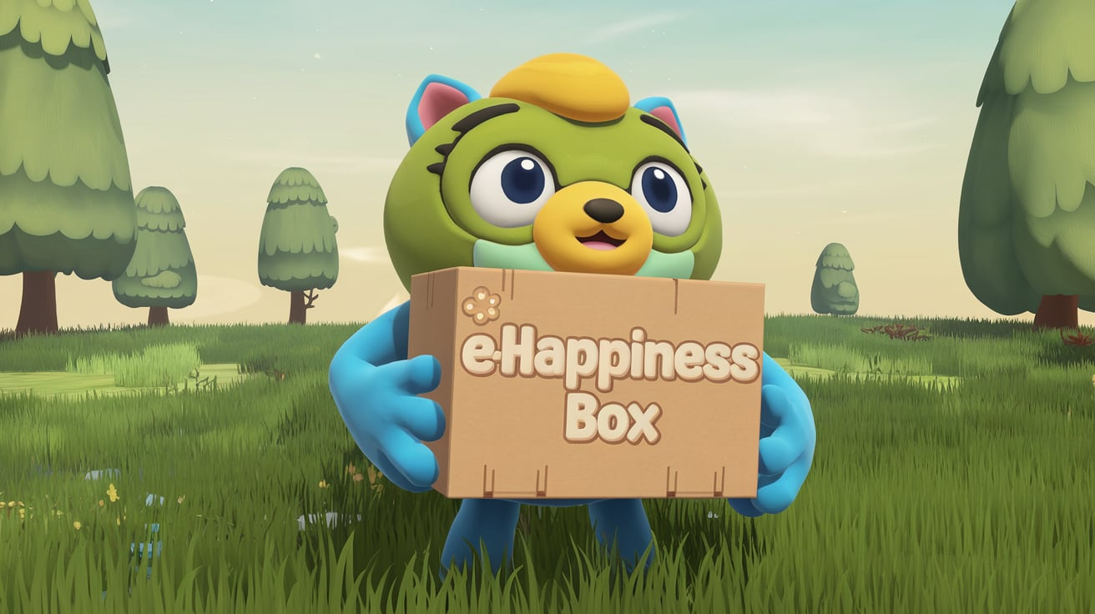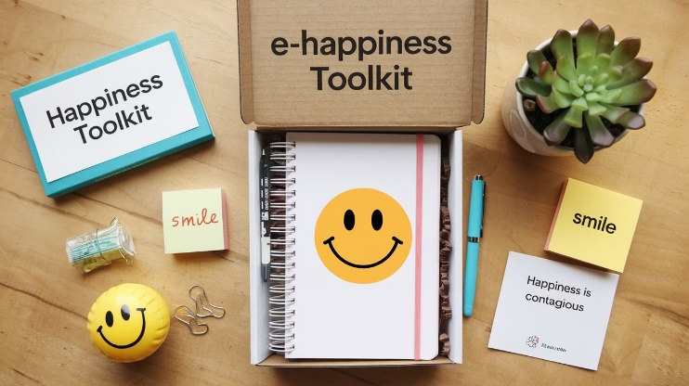Each e-Happiness Box contains 2-3-4 etc Do-It-Yourself happiness and well-being toolkits (***digital assets***) that can be used together to relish the Happiness Box impact. The e-Happiness Boxes are designed by able and passionate volunteers.

* **Explore (Download)**
* **E-Happiness Box 1: Physical Well-being**
* **E-Happiness Box 2: Social Well-being**
* **E-Happiness Box 3: Digital Detox**
* **E-Happiness Box 4: Spiritual Well-being**
* **E-Happiness Box 5: Well-being and Self-care**
* **E-Happiness Box 6: Volunteer Management**
* **E-Happiness Box 6: Advocacy and Awareness**
* **E-Happiness Box 6: Community Engagement**
* **E-Happiness Box 6: Fundraising and Development**
* **E-Happiness Box 6: Skills Development**
* **E-Happiness Box 7: Emotional Care**
* **Blog**

Dive into our Blog for articles, updates, and thought pieces on happiness, well-being, and community support. Our blog is a resource for inspiration and practical advice to help you lead a happier life.

* **Blog**
* Upload your articles for our Blog
* Step 1: Sign up through our online form below.
* Step 2: Attend a virtual / offline orientation to align with foundation goals.
* Step 3: Begin contributing to projects that resonate with you.

Join us in our mission to create happier, healthier communities worldwide!

**FAQ Section:**

• **Resource Library:** Offer downloadable materials or guides related to happiness and well-being, available to all visitors.(Pdf, videos, audios) with donate option-[pay as you go]

• **Newsletter Signup:** Encourage users to sign up for updates on future workshops and events.

---------------------------------

**Ellipsis of Happiness Foundation Volunteering Form**

**Personal Information**

* **Full Name:**
* **Age: Gender:**
* **Mobile Number: Whatsapp Number:________________**
* **Email Address:**
* **City: State:**
* **Social Media Handles (if any) (optional):**
  + Instagram:
  + LinkedIn:
  + Twitter:

**Volunteering Opportunities (Select Your Interest)**

* + **Harshvardhan (Local level)**
  + **Khushi ke Doot (Regional level)**
  + **Internship Program**

**Skills and Experience**

* **Please describe any relevant experience or skills you have that may be applicable to your volunteering role:**

**Additional Information [Optional]**

**Is there anything else you'd like to share about yourself or your motivations for volunteering with us?**

**[Submit]**

**D. Donate (SAMPLE** [**https://www.akshayapatra.org/onlinedonations**](https://www.akshayapatra.org/onlinedonations) **)**

1. **Sponsor Happiness Workshops**

Support our mission to spread happiness and well-being by sponsoring a workshop for students and communities. Your contribution will cover the costs of organizing, materials, and facilitation. Choose an amount that aligns with your giving capacity:

* ₹500\₹1,000\₹2,500\₹5,000\₹10,000\₹25,000\₹50,000\₹1,00,000\Other
* Sponsor one workshop ₹1000
* **Goal**: ₹5,00,000 [ Put Animated progress bar]

1. **Donate in Memory**

Honor the memory of a loved one by making a donation in their name. This meaningful gesture supports our efforts to create happier communities. Choose from the following amounts:

* ₹500\₹1,000\₹2,500\₹5,000\₹10,000\₹25,000\₹50,000\₹1,00,000\Other

1. **Donate in Honor**

Celebrate someone special by making a donation in their honor. Your contribution will help us continue our work in promoting happiness and well-being. Select an amount from the options below:

* ₹500\₹1,000\₹2,500\₹5,000\₹10,000\₹25,000\₹50,000\₹1,00,000\Other

1. **Sponsor Annual Student Scholarship**

* Become a sponsor for our annual Mr. and Miss Happiness™ student scholarship event. Your sponsorship will empower deserving students to further their passion for spreading happiness and well-being in their communities. These scholarships will enable impactful initiatives in mental health, well-being programs, wellness retreats, and physical fitness training, nurturing a brighter future for all
  + **Sponsor a Student: ₹12,000 per Scholarship**  
    Your contribution will directly fund a student’s journey to bring happiness and well-being to their community.
  + **Total Scholarship Fundraising Goal: ₹1,00,00,000**  
    Help us reach our target to empower hundreds of students to make a lasting impact.

1. **Adopt a Ph.D. Scholar, Empower Happiness**

Transform research into real-world impact by supporting a registered Ph.D. scholar. Your contribution helps turn academic insights into practical solutions for community well-being. Choose a donation level that reflects your commitment to fostering happiness via research:

* + Photos of Ph.d. Scholars
  + ₹500\₹1,000\₹2,500\₹5,000\₹10,000\₹25,000\₹50,000\₹1,00,000\Other
  + Goal: ₹50,00,000

1. **Adopt a School of Happiness**

* Invest in the future of happiness by adopting a Happiness Committed School for an entire school year. Your contribution will establish a dedicated Student Happiness Cell, providing ongoing support and resources at just ₹2,000 per month. Your generosity will create a lasting impact on the students' well-being and holistic development, fostering a happier, more resilient community.
  + Details and photos of School
  + ₹500\₹1,000\₹2,500\₹5,000\₹10,000\₹25,000\₹50,000\₹1,00,000\Other
  + Goal: ₹24,00,000 (24,000 per year for one student cell)

1. **Start Your Fundraising Happiness Campaign**

Launch your own fundraising happiness campaign and make a direct impact on our mission. Whether through a community event or an online drive, your efforts will help spread joy and well-being. By creating a campaign, your story and passion will be highlighted on our platform, inspiring others to join the cause. Additionally, you will have the opportunity to create a unique page for your campaign, showcasing your journey and encouraging others to contribute. Invite friends, family, and colleagues to amplify the impact, and receive regular updates on the difference you're making.

1. **Support Dial Happiness: One Month of Joyful Connections**

Help us keep the lines of happiness open by supporting our Dial Happiness Helpline. We aim to ensure that individuals have access to positive, uplifting conversations that brighten their day. This valuable service aims to spread happiness one call at a time!

* Details and photos of Dial Happiness Volunteers
* ₹500\₹1,000\₹2,500\₹5,000\₹10,000\₹25,000\₹50,000\₹1,00,000\Other
* Goal: ₹6,00,000 (4000/ month) (Helpline active for - next_??_ months)

1. **Contribute to Joy- Joyfully share your Time, Skill, Books, Referrals & Research Skill**

Contribute to our cause by joyfully contributing your time, skills, books, or referrals. Your skill expertise and resources can make a significant impact on our initiatives and help us fulfil the foundation’s vision of building conscious communities.

**DETAILS FOR BANK TRANSFER (NEFT/ RTGS)**

NAME OF FOUNDATION: ELLIPSIS OF HAPPINESS FOUNDATION

ACCOUNT NUMBER: 924020042806737

BANK : AXIS BANK

TYPE: CURRENT ACCOUNT

IFSC CODE: UTIB0003158

BRANCH: KAUSHAMBI

ADDRESS: PROPERTY NO 4, SECTOR 14, KAUSHAMBI, GHAZIABAD, UTTAR PRADESH, INDIA

**Please note that if you do not provide your PAN Number, you will not be able to claim 50% tax exemption u/s 80G in India**

Your information is collected as required by government regulations and will remain confidential. By sharing your details, you agree to receive updates from us via mobile, WhatsApp, email, and post. To change this, email us at **webmaster@ehappinessfoundation.in**.

I declare that I am an Indian citizen, and this donation is from my personal funds. The information provided is correct, and I understand that further communication will be sent to the contact details I have shared.

Sample website : <https://www.cry.org/ensure-young-girls-complete-their-education/?utm_content=hm-pooripadhai24>

Form

*Thank you for your interest in Non-Monetary Joyful contribution to our cause! Please fill out the form below to let us know how you would like to contribute non monetarily.*

**1. Contact Information**

**Name:** [Text Field]

**Email Address:** [Text Field]

**Phone Number:** [Text Field]

**2. How would you like to contribute?**  
*Please select all that apply and provide detailed information for each selected option.*

**a. Time**  
*Please specify the amount of time you wish to give:*  
Day [Mon/Tue/Text Field] Hours per week [Text Field]

**b. Skills**  
*Please describe the skills you can offer (e.g., graphic design, writing, project management):*  
[Text Field]

**c. Books**  
*Please list the books you wish to donate and their condition (e.g., new, gently used):*  
[Text Field]

**d. Referrals**  
*Please provide the names and contact information of individuals or organizations you think might be interested in supporting our cause. Include any relevant details that might help us approach them effectively, such as their area of interest or previous involvement in similar causes:*

1. **Name:**  
   **Organization (if applicable):**  
   **Contact Information (Email/Phone):**  
   **Relevant Details:**  
   [Text Field]
2. **Name:**  
   **Organization (if applicable):**  
   **Contact Information (Email/Phone):**  
   **Relevant Details:**  
   [Text Field]
3. **Name:**  
   **Organization (if applicable):**  
   **Contact Information (Email/Phone):**  
   **Relevant Details:**  
   [Text Field]

*Feel free to add additional referrals on a separate sheet if necessary.*

**e. Research Skills**  
*Please detail the type of research skills you possess and how you can assist (e.g., data analysis, literature reviews):*  
[Text Field]

**3. Additional Comments or Questions**  
*If you have any further information to share or questions for us, please include them here:*  
[Text Field]

**Thank you for your support! We will get in touch with you soon to discuss how we can best utilize your contribution.**

-------------------------------

**Refund and Cancellation Policy**

**Purpose & Commitment:**

At **Ellipsis of Happiness Foundation**, we value and respect the financial contributions made by our supporters in India. We are dedicated to ensuring that all domestic donations are used effectively to promote happiness and well-being across communities. While donations are generally non-refundable, we recognize the importance of transparency and fairness, and we have established this policy to manage refunds under specific circumstances.

**Eligibility for Refunds:**

* **Donation Errors:** If an error occurs during the domestic donation process, such as double payments or incorrect amounts, we will consider refund requests made within 7 days of the transaction. Requests should be submitted in writing, including proof of the deduction, to our official address or email.
* **Event Cancellations:** Refunds for event registrations will only be issued in the event of a cancellation.

**Conditions for Refunds:**

* **Tax Exemption Certificates:** If a tax exemption certificate has already been issued, we regret that we cannot process a refund. If a refund is approved, the original donation receipt must be returned.
* **Transaction Costs:** If a refund is granted, any transaction fees incurred may be deducted from the refund amount unless the error was made by Ellipsis of Happiness Foundation.

**Refund Process:** Refunds will be issued using the original method of payment. For example, if a donation was made via credit card, the refund will be credited back to the same card.

**Responsibility & Communication:** All requests will be reviewed carefully by our team. We aim to maintain a trusting relationship with our donors by ensuring all donation processes are secure and transparent. Our team is committed to communicating respectfully and professionally with donors and resolving any issues related to refunds.

**Contact Information:** For refund requests or inquiries, please contact us at:

**Email:** webmaster@ehappinessfoundation.in, **Address:** B-66, KB BLOCK, 2nd Floor, Near KB 32, Kaushambi, Ghaziabad, Uttar Pradesh Ghaziabad, UTTAR PRADESH, Pincode- 201010 or contact us at 9891712003

Thank you for your generosity and understanding as we work together to spread happiness and well-being.

**Privacy Policy**

**Last Updated:** 17th Aug 2024

Ellipsis of Happiness Foundation ("we," "us," or "our") is committed to protecting your privacy. This policy outlines how we collect, use, and safeguard your personal information when you interact with our services, including our website [www.ehappinessfoundation.in](http://www.ehappinessfoundation.in) .

**Information We Collect**

1. **Personal Information:** We collect personal information that you voluntarily provide, such as your name, email address, and phone number. We may also collect information related to donations or event registrations or scholarships applications.
2. **Automatically Collected Information:** We automatically collect certain information when you visit our website, such as your **IP address, browser type, and usage data**.

**Use of Information**

We use the information collected to:

* Provide personalized services.
* Communicate updates, newsletters, and event information.
* Analyze website usage and improve our services.

**Cookies**

We use cookies to enhance your experience on our website by remembering your preferences and tracking site usage. You can manage or disable cookies through your browser settings.

**Data Sharing**

We do not sell, trade, or rent your personal information to third parties. We may share your data with trusted partners who assist us in operating our website or conducting our activities, provided they agree to keep this information confidential.

**Data Security**

We implement robust security measures to protect your personal information from unauthorized access, alteration, disclosure, or destruction.

**Your Rights**

You have the right to access, update, or delete your personal information. Please contact us at [webmaster@ehappinessfoudnation.in](mailto:webmaster@ehappinessfoudnation.in) to exercise these rights.

**External Links**

Our website may contain links to external sites. We are not responsible for the privacy practices or content of these third-party sites.

**Policy Updates**

We may update this privacy policy periodically. Continued use of our services constitutes your agreement to any changes.

**Contact Us**

For any questions or concerns regarding this policy, please contact us at [webmaster@ehappinessfoundation.in](mailto:webmaster@ehappinessfoundation.in)

**Terms and Conditions**

**1. Acceptance of Terms**

Welcome to the website of Ellipsis of Happiness Foundation (“Ellipsis”). By accessing and using this site, you agree to abide by these Terms and Conditions (“Terms”). Please read them carefully before using the website. If you do not agree with these Terms, please refrain from using our website.

**2. Use of Content**

* **Personal Use:** All content available on the Ellipsis website, including text, images, videos, and graphics, is intended for personal and non-commercial use only. You may download, print, and display content from the site solely for personal use, provided you maintain all copyright and other proprietary notices intact.
* **Prohibited Use:** You may not modify, distribute, transmit, reuse, repost, or otherwise use the content for public or commercial purposes without explicit written consent from Ellipsis. Unauthorized use of any content may violate copyright, trademark, and other laws.
* **Intellectual Property:** All intellectual property rights, including copyrights, trademarks, patents, and proprietary information, displayed on this site are owned by Ellipsis or licensed to it. No right, title, or interest in any such intellectual property is granted to you by your use of the site.

**3. User Contributions**

* **Non-Confidentiality:** Any information, ideas, suggestions, or materials you submit to Ellipsis via this website, including emails or comments, will be treated as non-confidential and non-proprietary. By submitting such materials, you grant Ellipsis an irrevocable, worldwide license to use, reproduce, modify, publish, distribute, and display such materials for any purpose.
* **Content Standards:** When contributing content, you must ensure that it is accurate, not misleading, and complies with all applicable laws and regulations. You are prohibited from submitting any content that is unlawful, defamatory, obscene, or otherwise inappropriate.
* **Liability:** Ellipsis does not endorse any user-submitted content and disclaims all liability for any loss or damage arising from such content.

**4. Privacy Policy**

* **Data Collection:** Ellipsis respects your privacy and is committed to protecting your personal information. Please review our Privacy Policy (link to privacy policy) for detailed information on how we collect, use, and protect your data.
* **Cookies:** Our website uses cookies to enhance user experience. By continuing to use the site, you consent to the use of cookies in accordance with our Cookie Polic (link to cookie policy).

**5. Disclaimers and Limitation of Liability**

* **No Warranties:** The content on this site is provided "as is" and "as available" without any warranties of any kind, either express or implied. Ellipsis does not guarantee the accuracy, completeness, or timeliness of the content and assumes no responsibility for any errors or omissions.
* **Limitation of Liability:** To the fullest extent permitted by law, Ellipsis disclaims all liability for any damages arising from your use of the site, including but not limited to direct, indirect, incidental, consequential, or punitive damages. If you find any content which is not authorized or licensed by you , we apologize and we will immediately within 7 -15 days after intimation to us at [webmaster@ehappinessfoundation.in](mailto:webmaster@ehappinessfoundation.in) with proof of violation. We will give credits to all involved if found consciously or coincidentally or via you as alert users.
* **Third-Party Links:** The site may contain links to third-party websites. Ellipsis is not responsible for the content or accuracy of any third-party sites and does not endorse any products or services offered on such sites.

**6. Termination**

Ellipsis reserves the right to suspend or terminate your access to the site at any time, without notice, for any conduct that Ellipsis, in its sole discretion, believes is in violation of these Terms, applicable law, or is harmful to the interests of other users or the Foundation.

**7. Governing Law and Jurisdiction**

These Terms shall be governed by and construed in accordance with the laws of India. Any disputes arising out of or in connection with these Terms shall be subject to the exclusive jurisdiction of the courts located in NCR, India.

**8. Changes to Terms**

Ellipsis reserves the right to update or modify these Terms at any time without prior notice. Your continued use of the website following any changes indicates your acceptance of the new Terms. It is your responsibility to review these Terms periodically.

**9. Contact Information**

If you have any questions or concerns regarding these Terms, please contact us at:

**Ellipsis of Happiness Foundation**  
**Email:** webmaster@ehappinessfoundation.in,

**Address:** B-66, KB BLOCK, 2nd Floor, Near KB 32, Kaushambi, Ghaziabad, Uttar Pradesh Ghaziabad, Uttar Pradesh, Pincode- 201010

Contact us at 989-171-2003

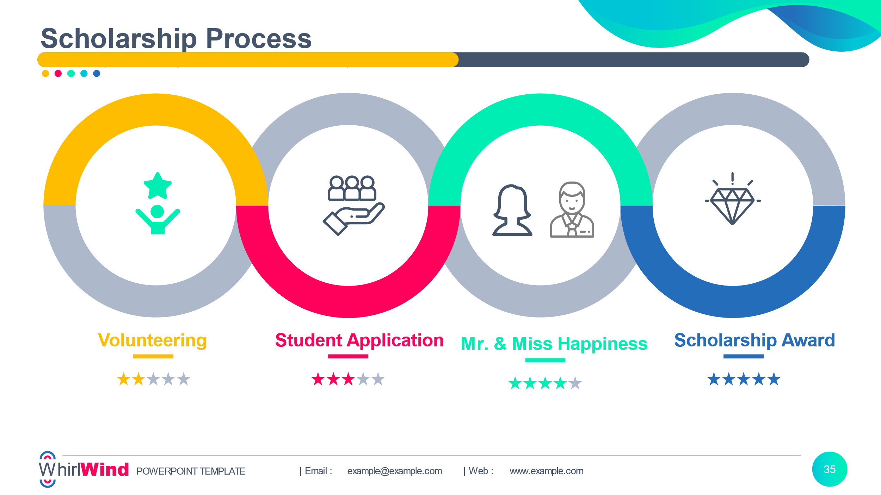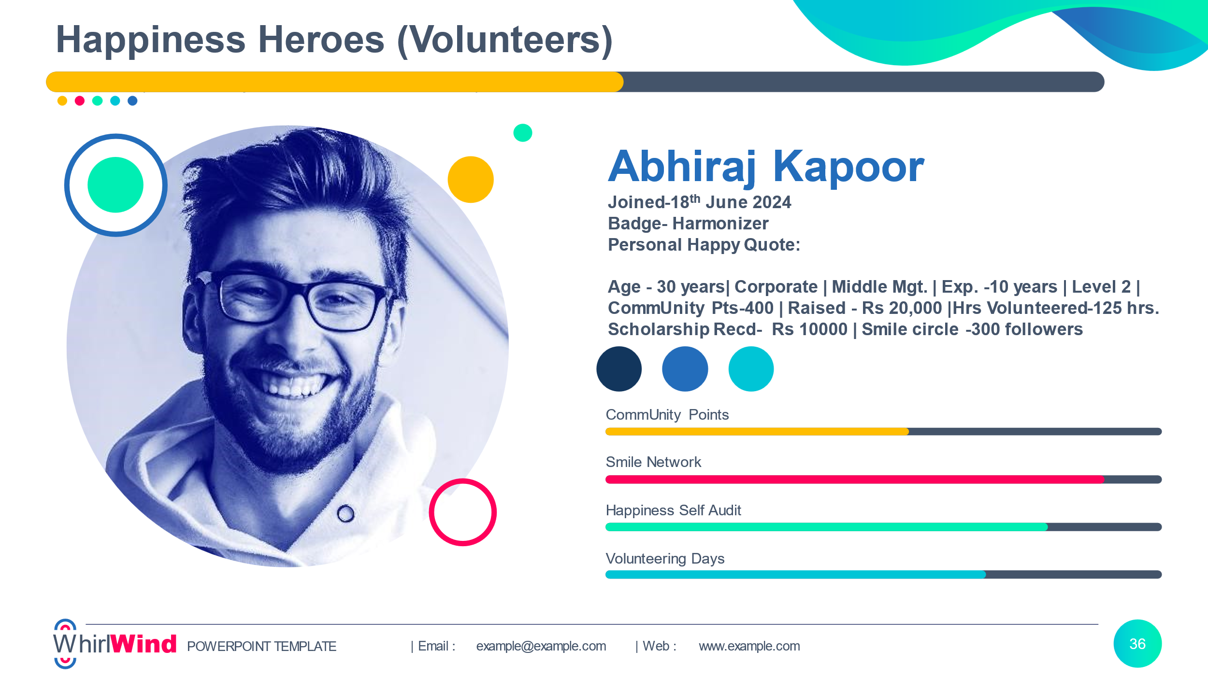

**Happiness Toolkits (Resources)**

**1.**

**2.**